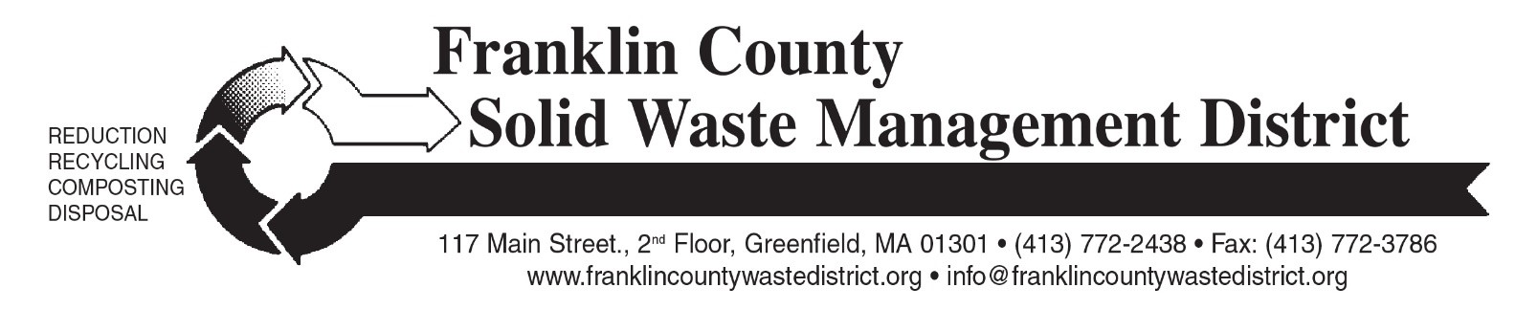

fall “Clean Sweep” Bulky Waste Recycling Day

Franklin County Solid Waste Management District is holding the Fall 2026 “Clean Sweep” Bulky Waste Recycling Day on Saturday, October 17, from 9 a.m. to noon. The two collection locations are Mohawk Trail Regional School at 26 Ashfield Rd. (Route 112 South) in Shelburne Falls, and Whately Transfer Station at 73 Christian Lane in Whately.
Please note that the collection is not being held at the Erving location this time. Area residents can bring materials to the other two bulky waste day sites or to Greenfield Transfer Station (separate pricing applies).
Residents and businesses from any of the District’s 21 member towns may bring bulky items to the two collection sites. There are charges for most items (cash only). A price list for the most common items is at: franklincountywastedistrict.org. Pre-registration is not required for Bulky Waste Day.
Acceptable items include tires, appliances, refrigerators, scrap metal, furniture, carpeting, construction debris, computers, televisions, propane gas tanks, bulky rigid plastics for recycling, and other large items. Materials will be recycled whenever possible. Please note that textiles and books are no longer accepted.
For more information, visit franklincountywastedistrict.org or contact the District at info@franklincountywastedistrict.org, (413) 772-2438. MA Relay for the hearing impaired: 711 or 1-800-439-2370 (TTY/TDD). The District is an equal opportunity provider.

