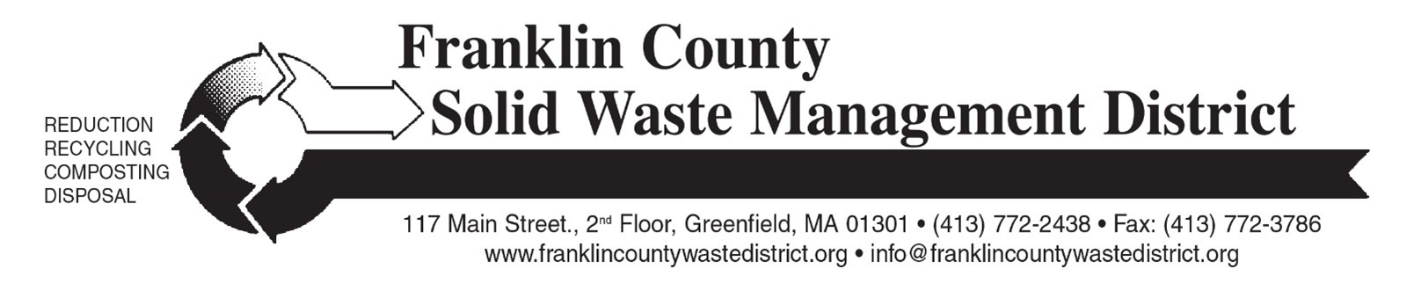

Save the Dates!
Franklin County Solid Waste District’s 2026 Collection Dates

Spring "Clean Sweep" Bulky Waste Recycling Day:
Saturday, May 16, 2026

Household Hazardous Waste Day:
Saturday, September 19, 2026
Pre-registration is required for Haz Waste Day; registration opens in mid-August.

Fall "Clean Sweep" Bulky Waste Recycling Day:
Saturday, October 17, 2026

Fees are charged for most Clean Sweep items. Pricing subject to change.
Household Hazardous Waste Day is free for residents of most towns.

For more information on these events, including locations, participating towns, hours, and pricing: https://franklincountywastedistrict.org/

Franklin County Solid Waste Management District: info@franklincountywastedistrict.org or 413-772-2438. MA Relay for the hearing impaired: 711 or 1-800-439-2370 (TTY/TDD). The District is an equal opportunity provider.

