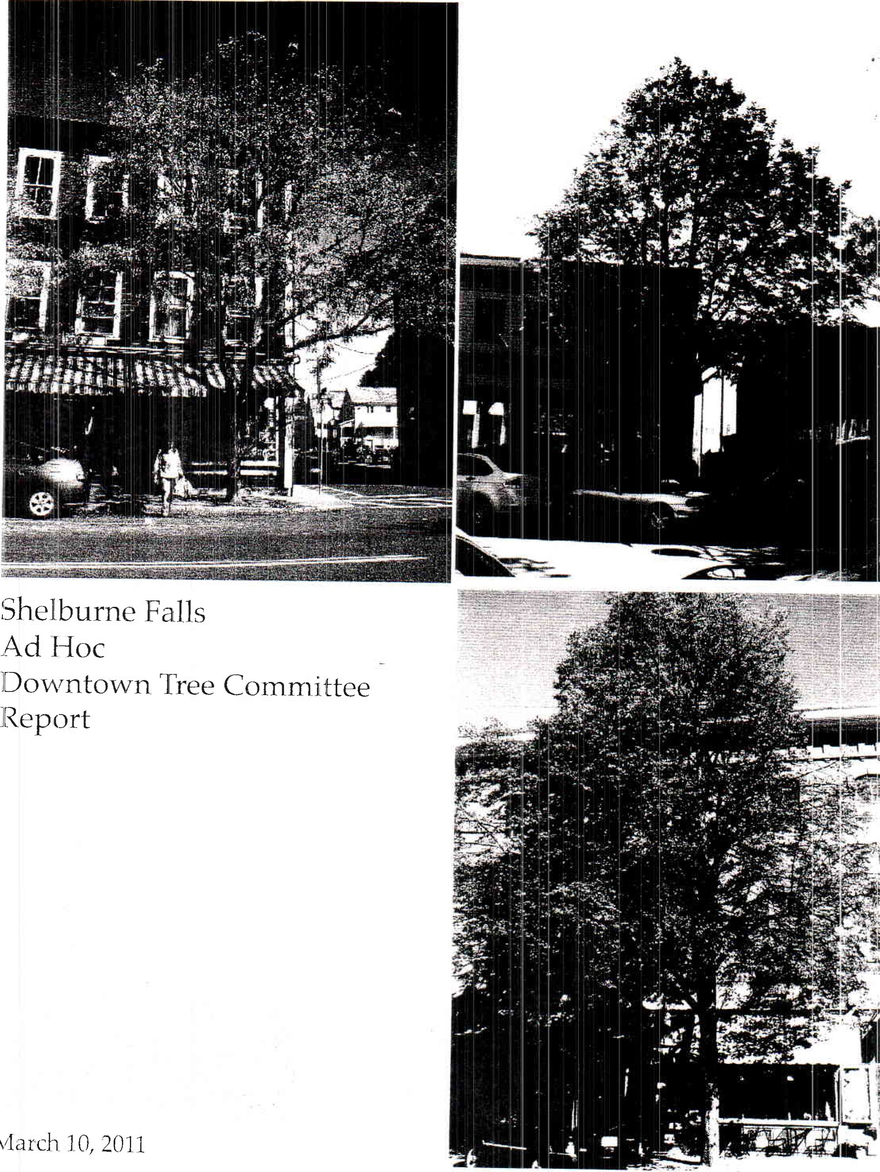
March
REPORT OF THE SHELBURNE FALLS DOWNTOWN TREE COMMITTEE
March 10, 2011
The Shelburne Board of Selectman appointed an ad hoc committee to assess the trees on Bridge Street (from Mechanic Street westerly to the Bridge), and make recommendations thereto. The volunteer committee consisted of five Shelburne residents including James Richardson Tree Warden, Brock Cutting, Kevin Parsons, Susan Reed, and Jeremy McGeorge. The committee began holding meetings in August, 2010 and continued through March, 2011. In the fall of 2010 the Committee distributed a questionnaire to property and business owners on Bridge Street. (The questionnaire and summary of the results are attached to this report.) On January 11, 2011 the Committee held a public hearing. The Committee also solicited the assistance of an arborist who has expertise in trees existing within a downtown area.
The Committee recognizes the work done by the Tree Committee which worked in
1976-78 to bring trees to the downtown. Prior to 1978 the downtown had no trees. The "Trees for Shelburne Falls" report done in 1978 set forth the work of the committee and list of donors with stories of those important community members that had trees dedicated to. This report provided the committee with interesting reading and more importantly an appreciation of the need to preserve what was started over thirty years ago. (A copy of that booklet is attached.)
A number of Bridge Street trees planted in 1978 have died and have not been replaced. Some of the existing trees need to be replaced. Some trees just need more maintenance. The trees that presently exist on the street have already outlived their life expectancy. The average life expectancy for a tree located in a downtown is approximately 20 years.
It is the opinion of the Committee the town needs to recognize the importance of the downtown trees and insure they are properly cared for. The Tree Warden budget for downtown tree maintenance and tree replacement is grossly inadequate. Many of the problems that exist could have been avoided and/or minimized if there were sufficient funds to pay for a regular maintenance program.
The Committee believes a long term plan, including a regular assessment and replacement schedule. The Town needs to avoid a situation in which the town is confronted with a number of blank spaces without trees as is presently the case. To that end, the Town must provide sufficient funding on an annual basis for the care, maintenance, and replacement of the trees as necessary. A number of property and business owners have indicated a willingness to contribute toward tree replacement. The Committee believes there is ample opportunity to enter into a public /private partnership for a tree replacement program. There is also opportunity to utilize Chapter 90 funds as a partial funding source for tree replacement. Although other potential grant opportunities could be explored it is the opinion of the Committee the town should find a way to insure proper funding for a care and maintenance tree program for decades to come.
Attached hereto are the specific recommendations of the Committee.
SF Ad Hoc Tree Committee Recommendations
The following recommendations represent the committee's commitment to protecting the civic amenity and economic benefit of street trees in the village of Shelburne Falls, while also ensuring the safety and comfort of residents, property-owners and visitors.
General recommendations
Sidewalk/Ground
The condition of the sidewalks throughout the downtown is good and well within the normal range; a few exceptions are noted below.
- The DPW has done a very good job leveling trip hazards with their present equipment; there's no need to invest in other equipment specifically designed for this purpose.
- There is no benefit to widening existing planting holes for mature trees, since the tree roots are already well beyond the edges of those holes.
- Any future planting should be done in the largest possible hole; long, slender planting holes oriented parallel to the street should be considered where the sidewalk is narrow, to maximize soil volume without reducing walking space. In some cases, these beds may even be long enough to contain two trees, positioned at least 20' apart.
- The ground surface within all planting holes should receive the same cover treatment to help create a consistent look for the downtown, ideally a porous but walkable material that prevents weeds, excludes dog action, can move in response to frost action and will not girdle the trunk. Recommended materials are bricks, concrete pavers or interlocking rubber pavers. In no case should landscape fabric or tree grates be used.
- Use of flexible permeable paving in a strip along the curbline will help avoid the heaving across the entire sidewalk width that is seen with large, monolithic concrete slabs abutting undersized tree pit openings.
- All existing landscape fabric and tree grates should be removed.
- There is no benefit to retro-fitting existing tree holes with alternate sub-surface planting systems or materials designed to push roots downward or away from buildings. In locations where a tree is being added or replaced and the sidewalk is also being replaced, these systems may be considered (see reference below). The best method of planting trees without replacing existing sidewalk is simply to make the hole as wide as possible and as deep as four feet, with larger holes needed for larger tree species.
The town should perform a regular, annual sidewalk assessment, and make a solid effort to remove all trip hazards.
SHELBURNE FALLS  TREE COMMITTEE
RESULTS OF SURVEY BY KEVIN PARSONS
October 19, 2010
I hand delivered and emailed questionnaires to all owners and businesses on Bridge Street that I was aware of. 16 owners and 7 tenants responded. (Singleys (4) and Gitsis Realty (2) are owners of multiple properties on Bridge Street.) The responses from these two entities were counted as one response for each property owned. The responses as to each property were somewhat different so I took each property as being a separate responses. I did not get response from Town of Shelburne for the Village Information Center, nor Peoples United Bank. I did not get a questionnaire to Bob Spencer who owns the two car garage building next to the Village Information Center. Otherwise all property owners on Bridge Street responded.
Question 1, have trees caused problems?
12 owners and 5 tenants said yes
2 owners said no
2 owners and 2 tenants did not answer either way
Question 2, Have trees created a positive experience? 10 owners and 3 tenants said yes
4 owners and 4 tenants said no
2 owners and I tenant did not answer either way
Question 3, Would you like more trees in front of your building?
5 owners said yes
9 owners and 5 tenants said no
2 owners and 3 tenants did not answer either way
Question 4, Would you like less trees in front of your building?
4 owners and 4 tenants said yes
8 owners and I tenant said no
4 owners and 3 tenants did not answer either way
Question 5, Would you like more or less trees on Bridge Street?
8 owners and 3 tenants said more
5 owners and 4 tenants said less
2 owners did not answer either way
I owner and I tenant said same
Question 6, Need of changes regarding care and maintenance of existing trees?
14 owners and 7 tenants said yes
I owner and I tenant said no
I owner did not answer either way
Question 7, Would you donate? 10 owners and 2 tenants said ves
6 owners and 5 tenants said no
I tenant did not answer either way

Make the Best of a Difficult Situation
Match the tree species to the available root space. and maximize root space and increase water infiltration by using these techniques
1. Enlarge the tree well dimensions,
- Use a porous pavement, such as dry-laid bricks in surrounding sidewalk so water can penetrate to the soil below
- Combine the planting area for several trees into a one continuous planting strip and tree roots will happily share space,
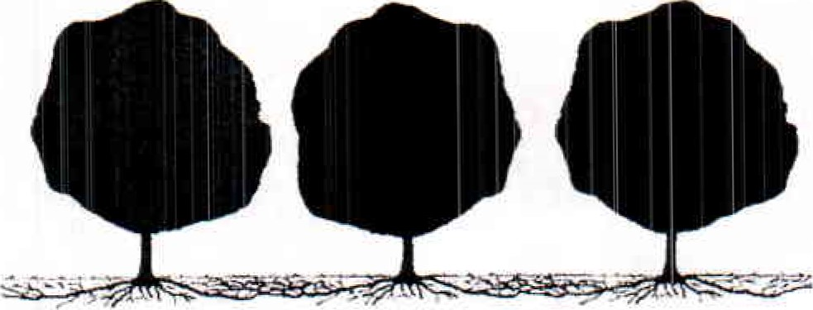
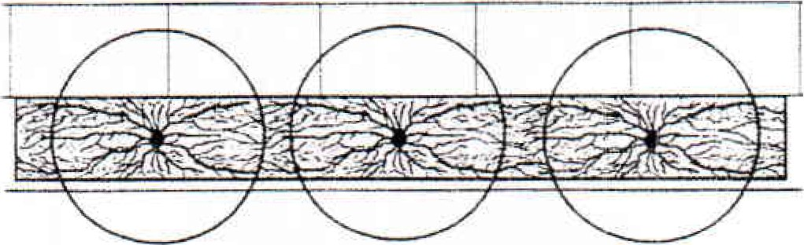
^{f}rom The Urban Tree Selection Manual John Alexopoulos, Paula Stahl and Robert Ricard
Example of continuous soil volume tree strip with pavers (brick & granite) layed over gravel layer and soil to allow water and air through but prevent compaction. use of a smaller paver module allows more flexibility - both in the surface of the strip area (root heaving) and in placement of street furniture such as signs, benches, etc.

  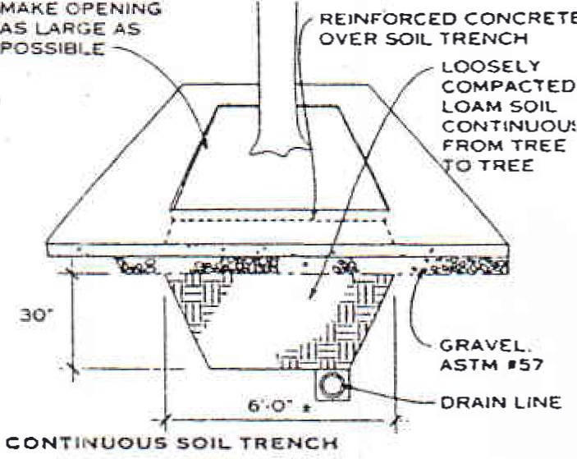
  CONCRETE
  NOTE
  A continuous soil trench provides very good soil but in iim. ited quantity. Use in areas whele adgacent backfill IS compacted 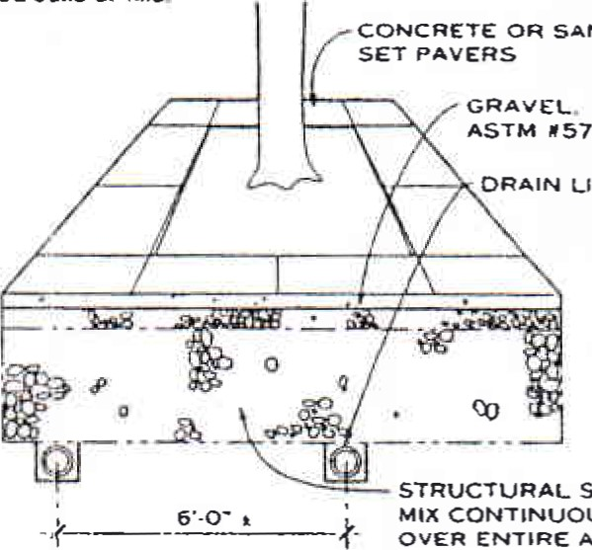sods or tills.
  SANO
  LINE
  sott-
  CONTINUOUS
  AREA
  STRUCTURAL sonNOTE
  Structural planting sods replace subgrade material with a felt that can oe compacted to meet normal engineering compaction requtrements and stilt support cool growth below the pavement. The principle ts that when the gravel is compacted. the soil i.^{e} . not because the amount of sod in the mix is insufficient to fill a" the voids. Hydrogei. a cross-linked potasssum copolymer. is used to help bind the mixture during the moon process. The S015 mix includes ASHTO grave* 000 1b calc' lated dry weight). shredded clay loam (15-18 1b). hydroge. (0.03 1b). and water ± 10 (tnciuding the water calculated in the gravel and the soil). For further information. contact the U'ban Horticulture Institute at Cornell University (Ithaca. NY)
  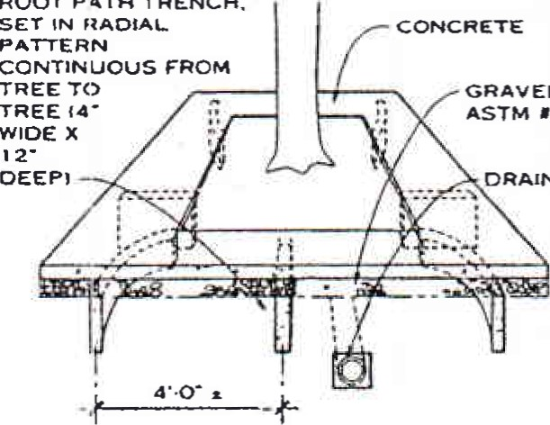DRAIN i.tNE
  ROOT
  PATH
  TRENCH.
  GRAVEL.
  157
  ROOT PATH TRENCH
  NOTES
  i. tn urban areas where the pavement subgrade is compacteci soil that is free from rubble. toxic, or poorty drained fills. a system of root can be installed to guide roots under the pavement. where they have room to grow. These roots grow deeper in the soil. causing fewer root]paving conflicts than roots left to exploit the t?ú'or weaknesses in pawng and subgrades.
  - A root path trench is made by installing a length of strip drain material (a 124n. wide x 1-in. thick plastic drain core wrapped in tilter tabnc) in a narrow trench and backfilling With loam topsoil. This allows air and water to flow more freely ^{I}nto the sod under the pavement- Instatt geotexti}e fabric and the gravel base material and then the paving.
  - Root paths cannot replace larger soil trenches or structural pianting soil in areas in which existing soil conditions are extremely poor fot root exploration
  TREE son- INTERCONNECTION
  OPTIONS UNDER PAVING
  GENERAL
  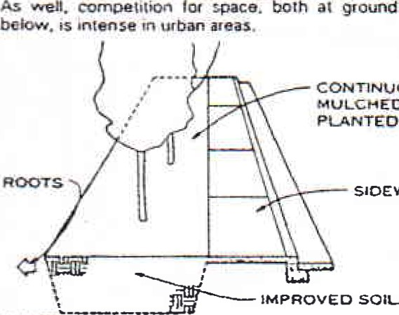
  rtacfltiortaå urban designs sn •whtch trees are requiarty spaced In small *Mlhin paved aceas result in poot tree performance. This because such designs generally do not provide adequate sod for root growth and fgnore tho tact that tgees must signif»cantiy tncreasø trunk size Avery year As
  ground
  level
  •and
  CONTINUOUS
  MULCHED
  OR
  SIDEWALK
  SOILS
  AREAS
  NOTE
  Best design option: Planting trees between sidewalks and buildings creates the fewest conflicts between roots and paving by permitting root'ng activity on adjacent property
  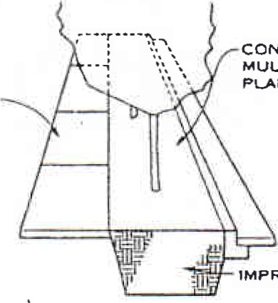
  CONTINUOUS
  MUUCHEO OR
  PLANTED AREAS
  SIDEWALK
  IMPROVED SOILS
  NOTE
  Acceptable design option: Planting between curbs and sidewalks in a continuous unpaved planting bed provides good sod levels for trees but coatnbutes to root/paving conflicts as trees mature.
  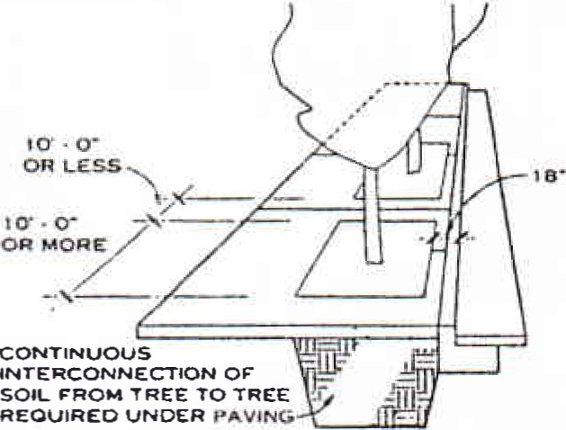
  NOTE
  Difficult design option: In highly developed areas With parking adjacent to the curb. planting in long narrow tree openings with an 18-in. wide walk along the curb accommodates pedestrians exiting cats Root/paving conflicts are probable.
  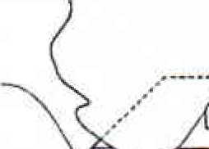  OPENINGS  LARGE  POSSIBLE  WALK |  |  |  | 
  AS
  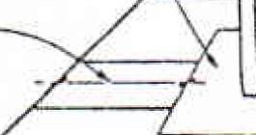
  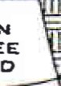  INTERCONNECTION  FROM TREE  REQUIRED  PAVING |  |  | 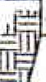
  MAKE
  AS
  AS
  MAKE WfOTH AS
  NARROW
  POSSIBLE
  AT TREE
  CONTINUOUS
  OF SOIL
  TO TREE
  UNOER
  NOTE
  Most difficult {and rms: expensive) dessgn option: Tree openings are undersized for future trunkftoot development. Severe tooUpaving conflicts are
  likely.
  SIDEWALK PLANTING OPTIONS
  James Urban. ASLA; Ulames Urbar, Landscape Architecture; Annapolis. Maryland
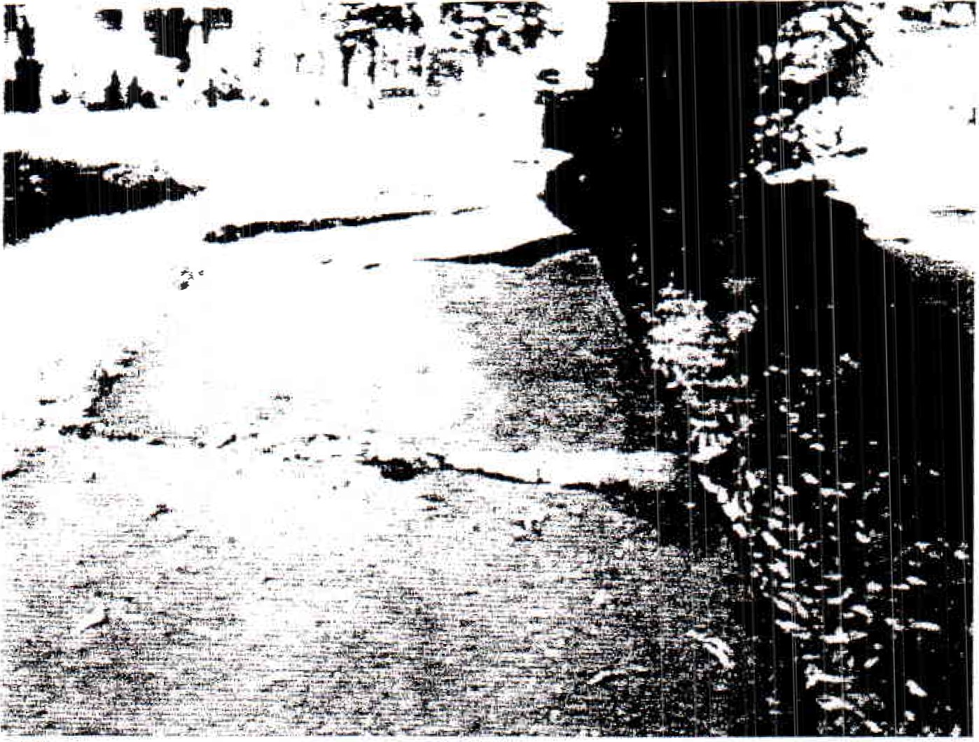
While this photograph is of a residential street sidewalk. It illustrates the problem of an undersized tree planting hole forcing the lifting of the entire width of the adjacent concrete sidewalk slabs..
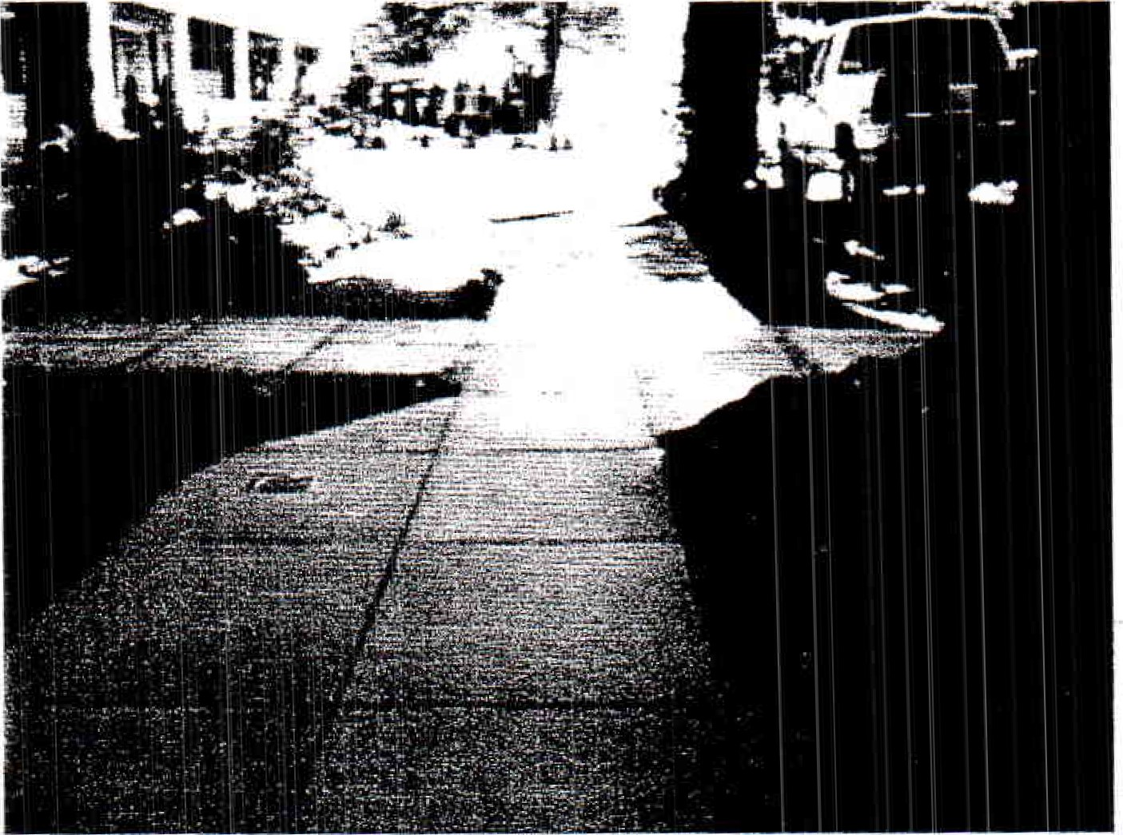
Interlocking, flexible rubber pavers made from recycled tires and tested for durability in freezing climates allow roots to flex pavement if necessary and not to force heaving of a monolithic slab across the whole width of the pavement.
Trees
- Most of the trees throughout the downtown are healthy and in good condition; see detailed recommendations below.
- Lindens are vulnerable to powdery mildew and aphids, creating an unpleasant black residue (sooty mold) on sidewalks, awnings and cars. Fertilizing unnecessarily can worsen this situation. Thinning the crown will help and, if done properly, reduce the chance of limbs breaking under a snow load.
- Overall pruning advice: remove deadwood and hazards, maintain building clearance and road clearance. In addition, thinning/ reduction pruning could be done on some of the larger trees with heavy lateral limbs.
- Any urban tree or trees must have a management plan, including regular monitoring to notice when any potentially harmful situation seems to be getting worse. Ideally, this should begin with an overall tree risk assessment.
- Therefore it is of critical importance that the Town increase the annual tree pruning and maintenance budget in the village.
- All new tree plantings should be provided with self-watering systems, such as a "gator-bag," to keep trees healthy while they become established. The town should implement a plan to educate property-owners and / or local "adopt a tree' volunteers about the need for regular watering.
Specific Recommendations
These recommendations refer to tree planting holes as indicated on the Shelburne Falls Sidewalk Improvement Plan produced by Dufresne / Henry in August, 1993. It should be noted that the 5 foot by 5 foot pits shown on these plans were changed in the field to be 30" x 30" pits and the loam underlying the area of the pit reduction was never stripped out and replaced with gravel for good drainage. This fact is a major contributor to the problems with these existing trees heaving the sidewalks. All new or replaced trees should have much larger tree pits and areas of prepared planting soil down to a depth of 4 feet.
The tree committee numbered these holes, starting at the bridge and moving east toward Arms Library; trees on the south side of Bridge Street have odd numbers, and those along the north side have even numbers. Each tree is further identified by its nearest store / office name. While this list of recommendations focuses largely on the trees themselves, a few sidewalk actions are also included here, where needed. For trees that are to be added or replaced (indicated in boldface type), see the separate list of recommended species, following this list.
- 16" Linden (Upton Massamont): Remove and replace tree with a new, smaller tree in a large, raised bed that will be enclosed on 3 or 4 sides by benches or other seating structure. The goal here is to create a new public gathering space that makes the most of this spacious sidewalk and appealing corner location beside the river.
- 24" Linden (Dick Muller Leather): Remove tree, remove sidewalk, replace sidewalk in its entirety and relocate planting hole closer to the bridge, where the sidewalk is wider, replace tree. Design a small raised planting structure here, to mirror the larger one just across the street, creating a sort of gateway or "head of the bridge" effect. Both of these structures, and perhaps others throughout the villaze. could be the focus of a region-wide design competition.
- No existing tree (Flower store): Add new tree, see recommended new tree at location #5 below.
- 14" Locust (Boswells): Prune tree vigorously.
- No existing tree (Judi's Hair): Add new tree, but move hole further away from intersection. Create new, linear planting hole that connects 3. and 5. Plant trees 20' apart.
- 14" Locust (Good Spirits): No action needed.
- 10"' Locust (Singley's): Prune tree vigorously.
- 17" Locust (Café Martin): Prune tree.
- 14" Linden (Foxtowne): Prune tree.
- 12" Linden (Arts Co-op): Replace tree, re-lay 3 new sections of sidewalk with new linear planting hole.
- 12" Linden (Mother's Pantry): Prune tree.
- No existing tree (Ken Chaffee): Existing planting hole is too close to street light.
Move planting hole 10' to the east (toward the bridge). Plant new tree.
- No existing tree, no planting hole, new sidewalk (Greenfield Coop Bank): Create new, linear planting hole, 25' long, and plant two new trees.
- 8" Locust (Keystone): No action.
- 8" Locust (Mocha Maya's): No action.
- 8" Locust (Keystone): No action.
6" Locust (Town Hall): Extend planting bed, toward mailbox; plant new tree further away from lightpost.
- 16" Locust (Keystone): No action.
- 2" Locust (Swan Building): No action now, but replace tree after building is replaced.
- 10" Locust (Baker's): No action.
- 10" Locust (Visitors Center): No action.
- 20" Linden (Greenfield Savings Bank): Prune vigorously and cable large leaders. Replace / raise sidewalk into bank entrance, where low spot will collect water and present a slip hazard when frozen. Add another new tree 20' toward the east. Optional: encourage the bank -to add another in the existing tree pit in front of the building.
- 10" Locust (Visitors Center): No action
- 14" Locust (Library): No action.
- No Tree
- 14" Locust (Library): No action.
Total replacement trees needed: 10 recommended, plus one optional
Recommended Replacement Tree Species
Note: During the growing season, the south side of the street is shaded by buildings, from morning through afternoon, while the north side of the street receives full sun for much of the day. The following recommended species reflect this situation, listed according to the hole numbers described above.
#1. Hophornbeam/lronwood (Ostrya virginiana); 25-40' height, 20-30' spread, native tree, small leaves, bright yellow color in fall, inconspicuous flowers, no fruit debris, salt-intolerant. Use this species only if this is a raised bed as recommended; if not, use the same species as in #2.
#2. American hornbeam/ Musclewood (Carpinus caroliniana); 25-40' height, 20-30' spread, native tree, small leaves, reddish-orange fall color, inconspicuous flower, no fruit debris.
#3. Apple Serviceberry/Juneberry (Amelanchier x. grandiflora, specifically either cultivar 'Autumn Sunrise', Autumn Brilliance' or 'Princess Diana'); 25-30' height, 15-20' spread, native tree, small leaves, orange fall color, abundant white flowers in late April, fruit in June taken entirely by birds. Single-stem only, no exceptions.
#5. Apple Serviceberry/Juneberry, same as tree #3, trees planted 20' apart, in 30' long linear bed.
#10 Siberian crabapple (Malus baccata, cultivar 'Jackii'); 20-30' height, 20-25' spread, non-native tree, small leaves, white flowers, purple-red fruit.
#12. Columnar Red maple (Acer rubrum 'columnare'); 40-60' height, 15-20' spread, native cultivar, large leaves, brilliant fall color.
#13. Gingko (Gingko biloba); 40-60' height, 30-40' spread, non-native tree, large unusual leaves, inconspicuous flowers. Plant 2 male plants only; females produce foulsmelling fruit and must be avoided.
#17. Downy serviceberry / Juneberry (Amelanchier arborea, specifically either cultivar 'Autumn Sunrise' or 'Princess Diana'); 25-30' height, 15-20' spread, native tree, small leaves, orange fall color, -abundant white flowers in late April, fruit in June taken entirely by birds. Single-stem onlyr no exceptions.
#22a. Downy serviceberry/Juneberry (Amelanchier arborea, specifically either cultivar 'Autumn Sunrise/ or 'Princess Diana'); 25-30' height, 15-20' spread, native tree, small leaves, orange fall color, abundant white flowers in late April, fruit in June taken entirely by birds. Single-stem onlyr no exceptions.
22b. Suggestion: plant another tree in the existing pit in front of the bank; recommended species: Washington hawthorne (Crataegus phaenopyrum); 25-30' height, 20-25' spread, native tree, small leaves, orange/ scarlet in autumn, white flowers, red fruit ( or Variegated River Birch 'Shiloh Splash' (Betula nigra Shiloh Splash'.
Future Tree Recommendations ro preserve continuity throughout the Downtown streetscape if a tree needs to replaced, or a new tree added, use the same species as those listed above. Carefully select according to shade-tolerance. This recommended species list would be different if prepared for the residential streets of the village since there the best place to site new trees is on the inside of the sidewalk (with permission on the abutting owner's property). Since this allows much more available soil volume to support the trees, species that reach larger sizes can be used.
North side (sunny):
- Hophornbeam (Ostrya virginiana)
- Columnar Sargent Cherrv ( Prunus sargentii 'Columnaris)
South side (shady):
Either side:
- Columnar Red Maple ('Bovvhall', 'Columnare')
Freeman Maple ^{E}Armstrong Il'
- Miyabe Maple (Acer miyabei)
- Columnar Siberian Crabapple (Malus baccata columnaris)
- American Hornbeam (Carpinus caroliniana)
- Apple Serviceberry (Amelanchier x. grandiflora)
- Fastigiate Gingko ( Gingko biloba 'Fastigiata', 'Sentry')
Conclusion
These street trees were planted in August of 1978 as part of the 'Trees for Shelburne Falls" memorial tree project of the Shelburne Falls Woman's Club. Each tree was given in memory of a specific person or group of people and the Town of Shelburne still has the marker plaques for each tree. For this reason and because the trees have been in the ground in these locations for what is now over 32 years they represent a significant resource of community memory, tree growth ,size and amenity for the Town. Consequently none of them should be removed and replaced without exploring all other possible options. None of them should be removed and replaced unless they are dead, almost dead or a safety hazard. It is also important to remember that extracting the dead trunk and roots of any of these trees is a very considerable and expensive project in the undersized tree pit openings that they have been confined to. Doing this will create significant damage to the surrounding sidewalks and is not to be undertaken lightly.
Careful and regular tree pruning and maintenance and judicious pavement shaving will alleviate many of the concerns of owners, tenants and citizens in the Downtown. As trees decline and are replaced the Town should make an effort to increase the variety of species above the two now present ( Thornless Honeylocust and Littleleaf Linden). An effort should also be made to increase variety in the ages of the different trees through adopting a rolling replacement plan of a few trees every few years. This is important so that they do not all reach the limit of their natural life span at the same time and need to be replaced leaving the Downtown "bare" for several years. Lastly, as trees are replaced every effort should be made to create longer and more continuous tree pits running parallel to the curbline. Ideally over time a continuous planting strip with a unified large volume of soil that could be shared by multiple trees would be created. This strip could be paved with smaller dimensioned pavers set with sand joints so as to allow them to let water and oxygen through to the tree roots, avoid compaction and allow removal of a small area rather than heaving the whole width of the adjacent poured concrete sidewalk
yo quote the Urban Tree Selection Manual by Alexopoulos, Stahl and Ricard "the value of urban (street) trees adds far more to our quality of life than the effort to select,
plant and maintain them. Trees provide many ecological or environmental benefits including:
- Increasing shade that reduces energy costs by 10-50% (and that adds comfort for street users)
- Decreasing storm water runoff
- Reduction of C02 and other greenhouse gases
- Cleaner air and reduced smog
- Better water quality
(Street) trees also provide many civic and cultural benefits, including:
- Enhancing our main thoroughfares
- (Providing comfort, interest and amenity)
- Adding to scenic quality for residents and visitors alike
- Increasing pedestrians and the economic viability of the Downtown
- Increasing real estate values
- (Creating a canopy that adds human scale and the presence of nature to the buildings of Downtown)"
In order to continue these valuable benefits, the Town of Shelburne should increase the annual tree pruning and maintenance budget in the village and the community should offer its support in the form of a new round of tree planting to continue the effort of the 1978 memorial tree planting effort.
Tree Information Sheets

References
Combined root deflector, soil aeration and watering systems for new trees in larger tree pits: http:/ / greenleafcanada.ca / products.html -- download pdf of catalog.
Flexible, recycled rubber pavers: http://www.rubbersidewalks.com/
Credits
Dirr's Hardy Trees and Shrubs, an Illustrated Encyclopedia, Michael A. Dirr, Timber Press, Portland , Oregon, 1997
Urban Tree Selection Manual, John Alexopoulos, Paula Stahl, Robert Ricard.

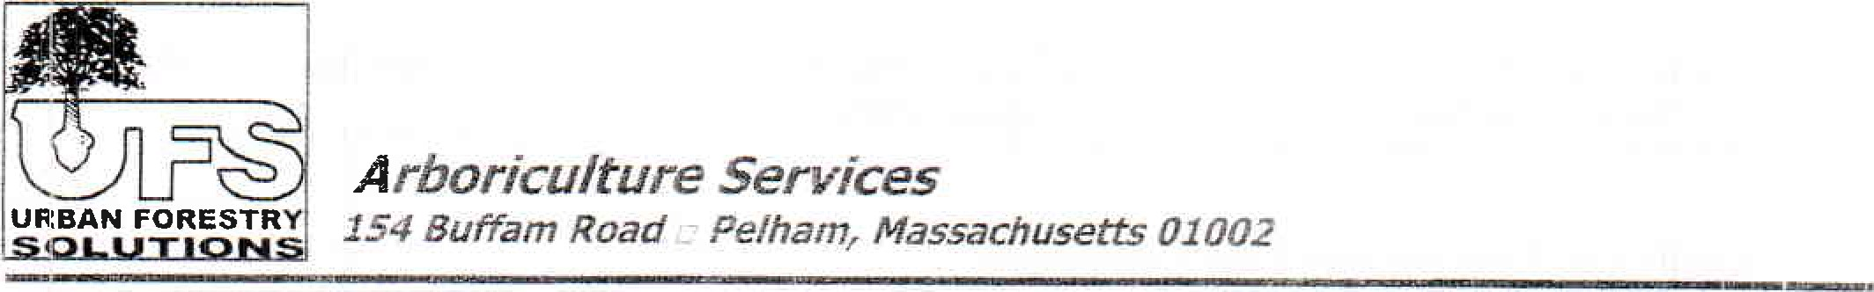
rboricu/ture Services
November
17,
2010
Buffam Road Pelham, Massachusetts 01002
James T. Richardson
Shelburne Tree Warden
349 Bardswell Ferry Rd.
Shelburne, MA 01370
Re: Downtown Shelburne Tree Assessment
Dear Mr. Richardson,
Brock Cutting requested that I send you this tree assessment report for the downtown area of Shelburne along Bridge Street. The information in the report is based on notes from a site visit and meeting between Brock, Sue Reed and myself that took place the afternoon of October 20th . This assessment focused on 21 street-side trees and 5 vacant planting spaces on both sides of Bridge Street from just west of Main Street eastward to the bridge. Also inspected was the large Zelkova tree just over the bridge in Buckland.
During our meeting and tree inspection, we addressed several concerns such as:
The health and structural integrity of the 21 existing trees
Impacts on infrastructure such as sidewalks, lights, buildings, signs and road clearance
Maintenance needs
Replacement plant species and appropriateness for that specific site
The following pages contain the bulleted notes compiled by Brock and Sue that were emailed to me. I have inserted comments where necessary. These will be in bold with my initials after each notation.
Please contact me if you have any questions, and I hope we get to meet someday.
Best regards,
Dave Hawkins, Consulting Arborist
Urban Forestry Solutions, Inc.
David C Hawkins — Consulting Arborist
Office/Fax: 413-253-4266 Mobile: 413-237-5106
Email: dhawkufqôcnmcaqt-net Weh: www-ufqtreeg-rnm

Shelburne Falls Ad Hoc Tree Committee
On-site consultation with Dave Hawkins, Urban Forester October 20, 2010
Overall Recommendations
- The general state of these trees and sidewalks is good and weil within the normal range; exceptions are noted below. DH: I thought the overall condition of the sidewalks was surprisingly good considering the average size of the trees. Although some heaving is taking place, I have seen much worse in similar situations.
All landscape fabric and tree grates should be removed and replaced with a pea-stone mulch Dr other porous surface material.
- There is no benefit to widening existing sidewalk holes for mature trees, since the roots are already well beyond those holes.
Lindens are vulnerable to powdery mildew and aphids, creating an unpleasant black residue on sidewalks, awnings and cars. They are also weaker and more vulnerable to breakage than the honeylocust trees. DH: Aphids and the honeydew they produce is common with littleleaf linden (less so with silver linden Tilia. tomanosa). Fertilizing the trees if they don't need it will make it worse. Thinning the crown will help and, if done properly, will also reduce the chance of limbs breaking under load.
- Some species recommended if trees need to be replaced:
o Columnar zelkova
Caller-y pear (aristocrat, greenspire, chanticleer) DH: decent tree but over planted.
- Amelanchier arborea (shade tolerant) - single stem form only. DH: Needs partial shade and is not drought tolerant. A nice small tree that will do well in areas shaded by buildings o Amur maple
Ornamental cherry (kwanzan, sargent)
Gingko (male only, to avoid malodorous fruit)
Pin oak (can be limbed up for clearance)
Red Oak - only in areas to inside of sidewalk where has room to spread. o Columnar varieties of English oak (Quercus robur)
Threeleaf maple (Acer triflorum), Nikko maple
Columnar Siberian Crabapple (Malus baccata)
- Species to avoid o Lacebark elm (too aggressive) o Maples (if concerned about Asian longhorn beetle)DH: I would not stop planting red and sugar maples yet (l feel that the ALB issue will be contained in Worcester). Red maples are still a great street and landscape tree.
- Ashes (if concerned about Emerald Ash Borer) DH: Green ash grows well in street side environments but is plagued by structural problems as it matures. I would use with caution.
- Overall pruning advice: remove deadwood and hazards, maintain building clearance and road clearance. DH: agree. In addition thinning/reduction pruning could be done on some of the larger trees with heavy lateral limbs. However, this can be time consuming, requires above average pruning skills, and may be beyond the scope of the tree maintenance budget.
- Planting systems designed to push roots downward don't work well unless there's a way to provide oxygen at those lower levels. DH: Agree. Root barriers may also restrict the roots to the planting area if they can't go under the barrier. Over time the roots will run out of room and resources. They are appropriate in long linear planting areas where the roots can run parallel to the barrier.
- Structural soil has not been proven to work well, as it causes roots to bend in potentially harmful ways. DH: Structural soils should be limited to new sidewalk construction with new plantings or sidewalk restoration where soil would need to be replaced with a load bearing, root friendly mix. The research has shown the roots tend to grow at angles around the stone rather than a linear fashion. The jury's still out on whether that's good or bad.
- Any urban tree or trees must have a management plan, including regular monitoring to notice when any potentially harmful situation seems to be getting worse. Ideally, this should begin with an overall tree risk assessment (would require about half a day of DH time for 26 downtown trees).
- For trees in first two years from planting: "Gator" watering bags are useful. Get owners and tenants involved in individual tree adoption watering program after providing them with clear watering instructions/specifications. DI-I: The key is educating the caretakers about watering needs. Watering too much can be just as harmful as no water.
- Future grants: 1. Obtaining "Tree City, USA" designation is a useful credential when applying far other grants. 2. Dave highly recommended contacting Eric Seaborn, head of the Urban Forestry program for Mass. DCR, since he has a good handle on what grant possibilities exist at that moment.
- Small machines exist for grinding sidewalk and Shelburne may want to consider getting one of these to encourage regular use as a way to deal with heaving problems. DH: These machines do exist but are expensive (approx. $3500.00). If the sidewalk heaving is happening in other areas of the town or could be shared with other towns, it may be justified. However, from what I saw, the Shelburne DPW has done a nice job leveling trip hazards with their present equipment.
Here's a link to sidewalk leveling equipment (http://www.contractorsdirect.com/Concrete.. Tools/Scarifiers)
- Suckering shoots need to be removed on existing trees. Cut as low as possible and coat with antisuckering tree paint. DH: this is limited to one linden. Prune each spring and fall and treat as necessary. Anti-suckering paint is available at most garden centers.
Specific Recommendations: numbers correspond to numbers on base map provided:
South side
1 Tree in good health; no action required; little decay and a weak branch attachment on the street side; see pruning notes above; optional idea if this tree is removed: create a large raised bed with seating on all four sides, since this is a natural gathering space and currently empty, and plant a smaller ornamental tree (crabapple, amelanchier).
3, Empty hole: best to use a vase-shaped tree here (see above)
5. Empty hole: bad location for a tree, too close to corner and lamp post; better to move hole closer to #3. 20' spacing is okay.
7. Remove tree grate; otherwise tree is in excellent health.
9. Tree in good health, no action required.
1 1 . Tree in good health, no action required.
13. No tree here now; recommend creating a linear planting hole along the edge of the sidewalk, long enough to support two smallish trees (for example: single-stem amelanchier).
15. Tree in good health; fill sunken hole with more pea stone mulch
17. Tree struggling and in conflict with lamppost; recommend lengthening the planting hole over to the mailbox and moving this or a new tree further away from the lamp.
19. Tiny, nearly dead tree; this is a great opportunity to plant a few larger trees beyond the sidewalk edge (recommended: pin oak, sycamore)
21. Fine, no action needed. 23. Fine, no action needed.
North side:
26. Fine.
24. Fine.
22 Good, maybe cable the large leaders to prevent a split; consider adding another tree in the targe space between 22 and 20. Remove, regrade and replace sidewalk at and near bank entrance, to eliminate low spot that may be icy in winter.
20. Fine.
18. Tree fine, remove grate
16. Tree fine, remove grate
14 Tree fine, remove grate
12. Tree gone, but hole too close to light; don't replace
IC. Suckering from the base; clip off all suckers as close to the base as possible and treat with antisuckering tree paint. Replace three sections of sidewalk.
8. Fine.
6. Fine.
4. Fine.
2. The largest tree on the street, with the most damaged sidewalk; would cause most damage if blew down. Recommend removal and replacement with a different tree in a new position, closer to lhe bridge where the sidewalk widens, perhaps in a raised bed. If decide to keep this tree, consider rernoving some of the large lower branches but avoid targe trunk cuts, and replacing several sections of sidewalk DH: Tree has outgrown is space and is competing with buildings, sidewalk and road. It is important to remember that all street side trees in planting pits are relatively short lived compare to landscape trees in non-sidewalk locations. 20 to 30 years is extraordinary; 10 to 15 year is more common.
Also, the large Zelkova over the bridge in Buckland is a great specimen in a good location. It is however, overgrown and in need of pruning. This should consist of raising the limb level over the road and plaza, thinning the crown and reduce by thinning the larger limbs with weak or Vshaped branch attachments.

