Shelburne Energy Committee
Monday, May 18, 2022 at 7:30 pm
Present: George Boettner, John Walsh, Pat Stevenson, Andrew Baker, Tom Johnson, John Walsh
Staff Person: Cynthia Boettner
Guests: Kay – Ashfield Energy Committee), Alia Woofenden – Community Engagement Liaison from the Mohawk Trail School District
Agenda
Mohawk Trail Community Engagement: Alia Woofenden described her role – has worked at MTRSD for 6 years in a variety of roles, as an environmental educator and now in this liaison role. Climate change is a big topic – starting a climate change class in 7th & 8th grade – looking at the community and the Mohawk Trail school complex. Want to focus on empowering students, not creating eco-phobia. Also doing a grant to do k-12 education in collaboration with an Ashfield culvert repair grant. Forming a Climate Change Ambassadors Club – working on invasive species, litter, gardening, solar, reduce trash, energy consumption. Formed an Outdoor Advisory Committee to get kids outside and working on environmental project.
Andrew referred Alia to FRCOG to learn about their county wide culvert mapping project. John Walsh noted that Robin Pease has historical energy use data for the school district.
Kay noted Generation 180/pathways/solar schools may have resources on solar
MassSAVE Community First Program: Cynthia wrote a summary of her activities which is attached to these notes. The tax insert letter is finalized and will be printed and sent in June. A brochure may go in the next tax bill. MassSAVE also recommends a dedicated stand-alone mailing for better response rate – Eversource might cover printing costs and possibly help with postage. The program is planning to provide phone numbers to local Energy Advocates so they don’t have to use their personal numbers – can set it up to ring through to the Advocate’s cell phone. Cynthia is also making a business card. Andrew suggested using Google Voice for doing phone calls and texting through the computer – very efficient. Cynthia will make available the recordings & slides of all the trainings she has been attending – will send Google drive link. Eversource will create a Shelburne google folder in which we can keep all of our outreach materials, photos and other stuff. There is a lot of pre-approved stock material available. Cynthia also shared the community tracking form for gathering data on events, news releases and other engagement. George noted that high oil prices is generating a lot of interest in mini-splits.
Andrew suggested doing a more focused effort on home tours – gather interested homeowners, and homes that feature heat pumps, solar, insulation, deep energy retrofits and other topics. He suggested networking with Guy Payne, director of SEON – Sustainable Energy Outreach Network – in Brattleboro, which has organized green home tours for many years and has recently done virtual home tours.
John expressed concern about the amount of bureaucracy. He suggested Cynthia set up a calendar over 3 months to help manage flex time, taking time off, dealing with training requirements, keeping the committee posted on scheduling, and insuring that we remain within the modest budget allocated for the Energy Advocate salary.

Postcard Project: Pat Stevenson reviewed the post card draft she sent out – approved by All In Energy. We can get 500 cards for $8 and have 300 students who may write out the cards. Students would write text in pencil and sign their first names, xx grade student at xx school. Could also have students illustrate front of card – in discussion. 860 residences in Shelburne. John suggested purging Highland Village, businesses and residents already served. Pat will follow up with Joe Judd about getting a voter list, sorted by street address if possible.
Minutes: Minutes of the April 21 meeting were approved with typos corrected – unanimous.
Home Energy Audits: Cynthia said there is a 2 month wait as of April for home energy assessments. John Walsh said he would look into other energy performance contractors.
Other Business
Green Communities grant –Cowell: No news on grant timeline. John thinks that we may hear the outcome of our application in August.
Solar on roof of Cowell Gym: Agreed to approach Andreas Schmid at Solect in summer when we have gathered info about Cowell, Pole Barn, 7 acres of apple orchard. Andrew would like to see if we can get him hired at Mohawk before we ask him for free consult.
Mohawk Solar: Andrew will get a date from the Mohawk Building Committee for their July meeting
New Business
Presentation at Town Meeting: Tom has created a 1 page report of Energy Committee activity that can be adapted to a Town Annual Report or written as a handout to be handed out to Town Meeting attendees.
Andrew asked the Committee for a 1 paragraph blurb for the e-newsletter – due next week.
John requested help checking the Town Energy Committee email – Pat will help.
Next Meeting June 16 at 7pm
Meeting Adjourned at 8:45 pm

Update Community First Partnership: April 22-May 17, 2022
Accomplishments since last meeting:
- All Weekly trainings attended (see below for details)
- Participation in all biweekly trainings
- John, Pat and Cynthia have been meeting weekly to discuss next steps
- Letter for tax bill insert completed, all permissions received, submitted to Angel, Town Treasurer. (Cynthia’s cell phone number is given on this.)
- Two conversations with Alia Woofenden (Mohawk School, with Pat). Re: Involving students in post card writing on June 15. Alia to attend 5/18 meeting to give us a better sense of her position and outlets for collaboration with the school.
- Business card drafted and ready for committee review. First iteration of review completed with CFP.
- Final of half-page flier revisions is in process by CFP program reviewers (adding town name, invitation to contact Cynthia directly, change wording so people aren’t led to believe they will get an immediate assessment)
- Note that Energy Advocates will be assigned phone numbers through which messages are routed to personal phone number.
- Working with All In Energy to find out why there is a waiting list to get an assessment. Solution may be to work with Home Performance Contractor instead of going through Clear Solutions and their assigned contractors.
- Contacted Laurie Wheeler at Arms Library who is interested in partnering. Haven’t set a time to discuss yet.
- Jeff has learned that a lot of Jeff and Cynthia’s nearby neighbors are interested in mini-splits and we wonder if we should schedule a pilot home tour to accommodate their questions. In the process, we could find out what kinds of questions people have and this will help the outreach committee design another similar event.
- Tried to get permission to hand out fliers at Bulky Waste Day (no response)

Next Steps (pending committee approval)
Pricing on outreach material printing
Design lawn sign?
Revise and Print business cards on stock from Staples; distribute to committee members
Reporting: press release, informal conversations
Home Tour focusing on mini splits (should be held after training on this topic in June)
Conversations/Planning Arms Library and Senior Center, if possible.
Research dates for events in Shelburne (Grange Fair, fundraiser dinners, check with Village Task Force for others)
CFP trainings are weekly:

Social Marketing (May 11): Goal is to find out what motivates people and what stymies them from being interested in the program, or, if they are interested, what obstacles stop them from getting an assessment. Then, even if they’ve had an assessment, what prevents them from taking the recommended actions. The CFP partners are trying to understand all of these barriers in hopes they can structure outreach and incentives for better participation. They have already been trying to address some of the financial barriers by upping incentives and rebates, like providing help in getting knob and tube wiring replaced, upping the insulation rebates for low and moderate income households to 100%, providing 0% heat loans.
The social marketing session talked mostly about how to conduct a focus group to better understand motivations and barriers. A focus group may not be the best approach for our little community, but we are encouraged to have candid conversations with individuals to get at these issues.
An online reporting form is now provided for keeping track of all our outreach activities and what we’ve learned from them, both on what’s working and what’s not. It’s due monthly, but they suggest filling it out at least weekly in order to capture our learnings while they are fresh in our minds.
Important: Any committee members involved in outreach activities should become familiar with the form. If not willing to fill it out after your encounters, you should at least have a chat with me so I can do it.
May 4, 2022: Deep Dive into Energy Assessments—this was packed with information, but went very fast.
May 18, 2022: Income Eligible Program— (upcoming as of this writing. I may have a conflict, but will watch the recording).

Draft business card (print is too small when we add the CFP- required blurb at the bottom, so needs revisions; Comments?)
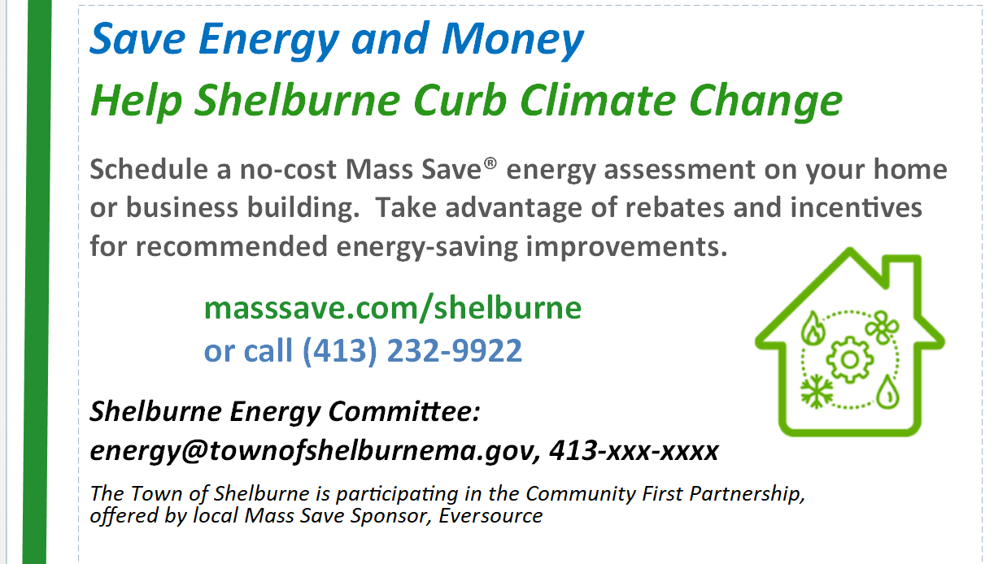
Suggested change: Replace paragraph beginning with “Schedule a no-cost ---” with:
- Get a no-cost energy assessment
- Financial incentives available

