REBID
REQUEST FOR QUOTES
RFQ 124502
Mechanized Mechanical Insulated Cellular Blackout Shades
Cowell Gymnasium 51 Maple Street, Shelburne, Massachusetts
Advertisement for Construction Services (MGL c. 149)
The Town of Shelburne, who is the awarding authority, is seeking price quotes from no less than three qualified contractors per MGL Ch 149 §44A (2) (b).
The Town of Shelburne will accept Price Quotes for the rebid of supply and installation of Mechanized Mechanical Blackout Shades at Cowell Gymnasium in the Town of Shelburne per the specifications. The Town will accept alternative bids for Manually Operated Blackout Shades. The Cowell Gymnasium is located at 51 Maple Street, in Shelburne, MA.
The RFQ must be downloaded from:www.townofshelburne.com ( Selectboard Files - Town of Shelburne, MA) in order to be notified of any updates, addenda, or clarifications. Quotes must be submitted by email. The quote, plainly marked "Rebid Blackout Shades - Shelburne Cowell Gymnasium” in the email submission Subject Line will be received by Terry Narkewicz at email address:
townadmin@townofshelburnema.gov
To submit an informed quote, Bidders are instructed to call John Walsh, Cowell Gymnasium Project Coordinator at 413-775-3274 to schedule an appointment to inspect and assess the existing conditions. Site visits by Bidders must be completed on or before January 23, 2026.
Price quotes that are incomplete, not properly endorsed or signed, or otherwise contrary to instructions may be rejected as non-responsive by the Town of Shelburne.
(Timelines subject to change)
Town of Shelburne
John Walsh, Cowell Gymnasium Project Coordinator
Date: January 19, 2026
The Town of Shelburne does not discriminate based on race, color, national origin, sex, age, disability, or gender with respect to admission to, access to, or operation of its programs, services, or activities.
RFQ posted to TOWN OF SHELBURNE Webpage 01/19/2026.
CRITICAL DATES
Deadline for Written Questions 3PM 01/28/2026.
Addenda sent to Bidders. 01/29/2026.
QUOTES DUE 3pm (Quotes submitted via Email) 02/04/2026.
ESTIMATED DATES
Quotes evaluated 02/05/2026.
Town Authorizes Contract 02/09/2026.
Work to be completed and invoiced no later than Ninety Days (90) from execution of contract unless product is backlogged.
General Information and Bid Instructions
General Conditions and Specifications
BID FORMS (all forms to be submitted to TOWN OF SHELBURNE)
GENERAL INFORMATION AND BID INSTRUCTIONS
1. All Quotes must contain a completed and signed Price Quote Form, Non-Collusion Form, and OSHA Certification Form, as provided.
2. If there are questions about the Quote, they must be submitted by the Bidder IN WRITING by email to walshjt@verizon.net on or before the end of day on January 28, 2026 at 3pm. An addendum will be issued, if one is necessary, to all who have downloaded the Request for Price Quote.
3. Samples of shade covering, photographs of or cutsheet must be provided with bid.
4. As the TOWN OF SHELBURNE is exempt from the payment of Federal Excise Taxes and Massachusetts Sales Tax, prices quoted herein are not to include these taxes. A tax- exempt form will be provided by the Town to purchase the materials.
5. The winning Bidder will be held to the terms and the prices on the Price Quote Form for the duration of the contract period if a contract is signed by both parties within 30 days of the Price Quote opening. The TOWN OF SHELBURNE reserves the right to reject all quotes, in total or in part.
6. The TOWN OF SHELBURNE reserves the right to request a performance bond provided upon signing a contract with the Town.
7. The Vendor will be bound by all applicable statutory provisions of law of the Federal Government and the Commonwealth of Massachusetts. The Vendor shall be responsible for obtaining a Building Permit, if required; however, the fee is NOT waived by the Town.
8. The Vendor will be required to indemnify and hold harmless the Town of Shelburne for all damage to life and property that may occur due to the vendor’s negligence or that of their employees, subcontractors, etc., during the contract period.
9. If in the judgment of the Shelburne Select Board, any property is needlessly damaged by an act or omission of the vendor, the number of damages will be deducted from money due to the vendor or may be recovered from said vendor in legal action.
10 Any inferior or damaged product, as determined by the TOWN OF SHELBURNE, will be replaced at the total expense of the Vendor.
11. Any restrictions, qualifications, or deviations from specifications must appear either on the Price Quote Form or an Attachment thereto.
11. RULE FOR AWARD: A purchase order/contract will be issued by the TOWN OF SHELBURNE to the lowest responsible bidder based upon quoted price taking into consideration past performance and reliability of the bidder, quality of product and/or service, and degree of exclusion, exemption, or restrictions on the Price Quote Form. The contract will include but not be limited to all general and specific conditions contained in the Invitation for Price Quote and the Quote submitted by the awarded bidder. Payment will be made by the Town within 30 days of satisfactory acceptance of the work. `
12. INSURANCE REQUIREMENTS
The Contractor shall always during the Contract maintain in full force and in effect Employer's Liability, Worker's Compensation, Bodily Injury Liability and Property Damage, and General Liability Insurance, including contractual liability coverage. All insurance shall be by insurers and for policy limits acceptable to the Town and before commencement of work hereunder the Contractor agrees to furnish the Town certificates of insurance or other evidence satisfactory to the Town to the effect that such insurance has been procured and is in force.
For the purpose of the Contract, the Contractor shall carry the following types of insurance in at least the minimum amounts specified below:
COVERAGES LIMITS OF LIABILITY
Worker's Compensation Statutory **
Employer's Liability $500,000/$500,000/$500,000
Automobile Liability bodily injury and property damage $1,000,000.00 combined single limit for
General Liability $1,000,000.00 each occurrence
$2,000,000.00 aggregate
Contact Person for Quote Information Town of Shelburne
John Walsh Cowell Gymnasium Project Coordinator
413-775-3274
The TOWN OF SHELBURNE, who is the awarding authority, is seeking price quotes from no less than three qualified contractors per MGL Ch 149 §44A (2) (b). Other submissions may be accepted at the Town’s discretion if they meet the qualifications, and three quotes are not received from qualified contractors.

PROJECT WORK SPECIFICATIONS
GENERAL
1.01 Work Included
A. Work under this section consists of the furnishing of all labor, materials, and equipment necessary for or incidental to the complete and proper installation of all window blackout shades as specified herein, and in accordance with the contract documents.
B. Material and installation shall conform to applicable building code requirements of all authorities having jurisdiction.
C. Blackout Shades must meet or exceed the “Attachments Energy Rating Council (AERC) Energy Improvement” rating or qualify for Federal Energy Efficiency Tax Credits for increased energy savings and added comfort. (The AERC energy rating indicates that the product has been certified according to strict standards set forth by the AERC. AERC is an independent, public interest, non-profit organization whose mission is to rate, label and certify the energy performance of window attachment products.)
1.02 Product Requirements
- Install ten (10) approximately 64“wide by 130” long Energy Efficient Motorized Cellular sun light filtering honeycomb commercial blackout shades with micro-shield. (fire rating is required for public spaces). As an alternative option, manually operated blackout shades should be proposed.
- Including additional costs to prepare windows for installation, and any additional carpentry needed to accept blackout shades and wiring in the window opening.
- Provide needed electrical connections to power all blackout shades (Town will provide electrical connection point). Connections must meet Massachusetts electric Code.
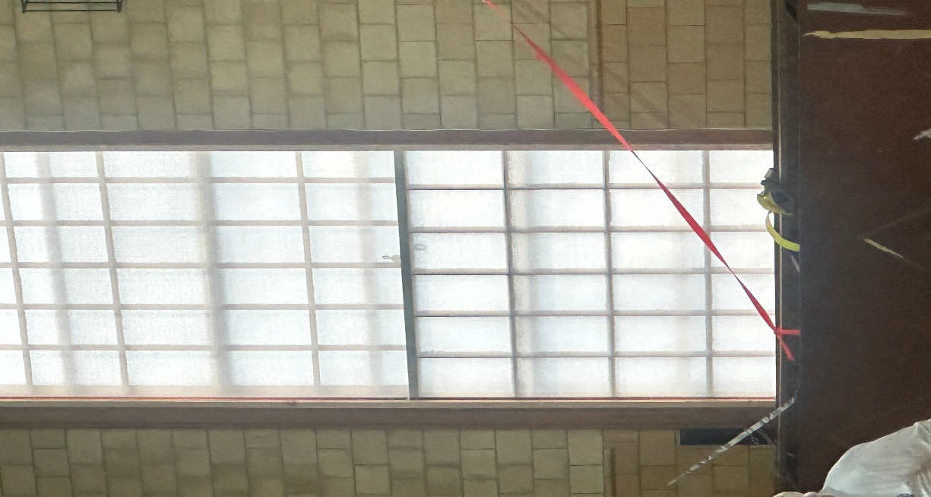
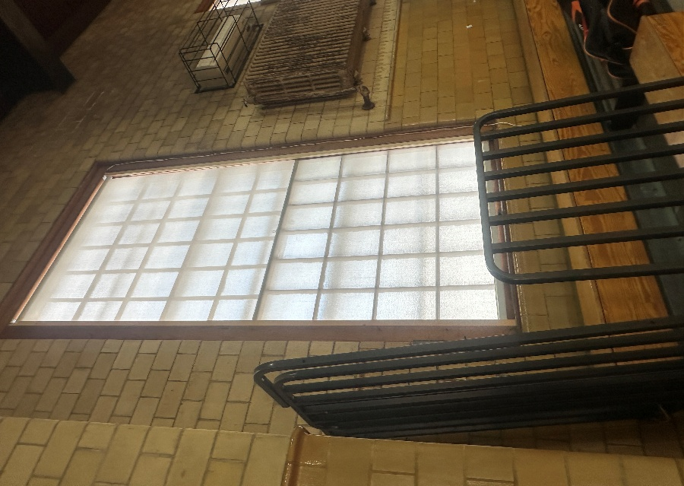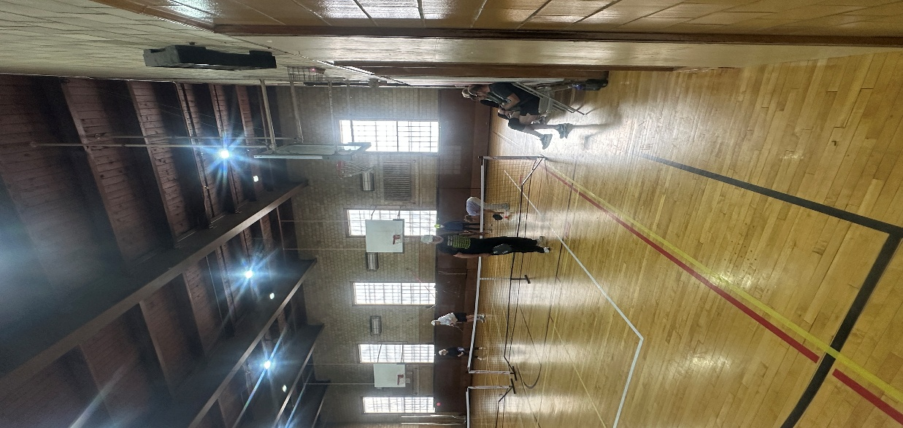

1.03 Delivery, Storage and Handling
A. Materials shall be protected from the weather and other damage.
C. Damaged materials found unsuitable for use will be rejected and shall be removed from the site.
1.04 Project, Site Conditions
A. Window blackout shades shall not be installed under conditions not approved by the manufacturer
1.05 Cleaning
A. After completion of work in an area, equipment shall be removed, and all surfaces shall be cleaned of all deposits of material.
GENERAL CONDITIONS
DEFINITIONS: Where “Cowell Gymnasium Project Coordinator,” “Awarding Authority” or “Town” is used, it shall mean the Town of Shelburne or their designee.
SUMMARY: The work consists of supplying and installing energy efficient Mechanized Insulated Window Blackout Shades at the Cowell Gymnasium per the plans and specifications provided. Alternative bids for non-motorized insulated blackout shades will be accepted.
The Work of the contract shall consist of all construction materials, labor, equipment, and services required by the specifications and other documentation, or as reasonably inferable from any or all the Construction Documents. The Work shall be for the whole of the project as described in the Construction Agreement.
The Work of the project shall comply in all respects with applicable federal, state, county and/or town regulations, laws, and codes. All required building and other permits shall be obtained before beginning construction.
All materials and workmanship shall be equal to the highest standard and shall be to the satisfaction of the Cowell Gymnasium Project Coordinator. Substitution of items will not be permitted unless specifically approved by the Cowell Gymnasium Project Coordinator in writing.
EXAMINATION OF DOCUMENTS AND SITE: Before submitting a bid, each bidder shall read the Specifications and all other Bidding Documents. Each bidder shall fully inform himself/herself prior to bidding as to existing conditions and limitations under which the Work is to be performed and shall include in their bid a sum to cover the cost of items necessary to perform the Work as set forth in the proposed Contract Documents. No allowance will be made to a bidder because of lack of such examination or knowledge. The submission of a bid will be considered as conclusive evidence that the bidder has done such an examination.
HAZARDOUS MATERIALS/ STOP WORK: If hazardous-containing materials are encountered during this work the Contractor shall cease removal work and immediately notify the Cowell Gymnasium Project Coordinator. Town-approved Work Stoppages will not apply to the liquidated damages deadline.
PROJECT MEETINGS: Unless otherwise directed by the Town, project meetings will be held to review project progress. Present at these meetings shall be a representative authorized to make commitments for action on behalf of the Cowell Gymnasium Project Coordinator, and the Contractor. The Cowell Gymnasium Project Coordinator shall write minutes of all meetings and distribute them within 72 hours of the meeting to all parties present and to those on the distribution list given out at the orientation meeting. The Contractor shall revise the schedule weekly and shall bring the revised schedule with a detailed week look ahead to each project meeting.
CONSTRUCTION TIME: The Agreement includes a stipulation that the Work be entirely completed within 8 weeks of execution of contract.
BUILDING PERMIT: It is the responsibility of the Contractor to apply for and secure a building permit for the Work if necessary. The Contractor is responsible for contacting the Town of Shelburne ’s Building Inspector for timely and required inspections of the Work. The permit fee for this work shall NOT be waived by the Town.
ACCESS TO BUILDING: Contractor shall be allowed access to the building and there will be no requirement for a Town representative to be on site. The Contractor shall assure that the building is secured and will use utmost care in always protecting Town-owned property.
ELECTRICAL SERVICE INTERRUPTION: Contractor may interrupt electrical service with planned notice to be given to the Town representative.
MODIFICATIONS: All requests to modify the project scope, specifications or drawings shall be submitted in writing by the Contractor and must be approved by the Cowell Gymnasium Project Coordinator in writing.

GENERAL SPECIFICATIONS
CONTRACT DOCUMENTS AND RELATED REQUIREMENTS:
The following specifications are considered minimum requirements for proper completion of the Work as described by the Documents. Provide all necessary permits, labor, materials, equipment, debris and demolition removal, safety procedures and supervision and all Project and Contract Closeout requirements and procedures.
• General provisions of the contract, including any supplementary conditions and other included specifications shall apply to the work of this project. The Documents show the work to be done under the contract and related requirements and conditions impacting the project. Related requirements and conditions include applicable codes and regulations, notices and permits, existing building conditions and restrictions on use of the building/site, requirements for Cowell Gymnasium occupancy during the work, coordination with other work and the phasing of the work. In the event the Contractor discovers a conflict in the contract documents and/or requirements or codes, the conflict must be brought to the immediate attention of the Cowell Gymnasium Project Coordinator for resolution. Whenever there is a conflict or overlap in the requirements, the most stringent shall apply. Any actions taken by the Contractor without obtaining guidance from the Cowell Gymnasium Project Coordinator shall become the sole risk and responsibility of the Contractor. All cost incurred due to such action are also the responsibility of the Contractor.
CONTRACTOR(S):
• The Contractor shall be solely responsible for the Work described in the contract agreement. S/he shall have complete control over construction methods, techniques and procedures and shall supervise such work with her/his best skill and attention. The Contractor shall pay for all labor, equipment, materials, and services required to complete the Work as described in the Contract Agreement as well as building permits and other governmental fees, licenses, and inspections necessary for the proper completion of the Work.
• The Contractor warrants that all materials and equipment required to complete the Work on the project will be of excellent quality and new.
• The Contractor shall take care in working near existing areas to protect them from damage. The Contractor shall be responsible for any damage to existing areas and will repair such damage, at their expense, to the Cowell Gymnasium Project Coordinator’s satisfaction.
• The Contractor shall keep the project site and surrounding area free from waste materials and rubbish which results from his work on the project. Providing a dumpster in the Cowell Gym parking lot area, removal, hauling and disposal of rubbish and waste materials shall be the responsibility of the Contractor. Costs for dumpster and hauling shall be included in the lump sum fee.
• The Contractor shall be held responsible for all damage resulting from his, or his subcontractors, errors, omissions, or negligence in the performance of the Work of the Construction Agreement.
• The Contractor shall hold harmless the Town and Cowell Gymnasium Project Coordinator from and against all claims, damages, losses, expenses, legal fees, or other costs resulting from the Contractor's performance of the Work of the Construction Agreement.
SUBCONTRACTORS:
• The Contractor shall select the subcontractors, except that he shall not use subcontractors to whom the Cowell Gymnasium Project Coordinator has a reasonable objection. The Contractor shall not be required to use a subcontractor to whom he has a reasonable objection.
OSHA:
• The work area shall be made OSHA safe by this Contractor. All workers must be OSHA trained and carry their OSHA cards.
JURISDICTION:
• This agreement shall be governed by the laws of the Commonwealth of Massachusetts.
CONTRACTOR USE OF PREMISES:
• The Contractor and Contractor's personnel, subcontractors and others providing portions of the Work of the project shall cooperate fully with the Cowell Gymnasium Project Coordinator regarding the use of the building to facilitate the Work.
PROJECT CHANGES:
• Changes, modifications, additions, and/or deletions to the Work under this agreement will only be made by a written order signed by the Cowell Gymnasium Project Coordinator and the Contractor. Any such changes will not invalidate this Agreement. The time for project completion and the project cost will be adjusted accordingly.
PERSONNEL PROTECTION:
• The Contractor is responsible for all safety and protection of all persons at the site of the Work including following all current Massachusetts COVID Workplace protection protocols.

Price Quote Form
Supply and Install Insulated Mechanical Blackout Shades Shelburne Cowell Gymnasium RFQ 124502

Pricing is according to the specifications provided within this Request for Price Quotes. All activities not expressly mentioned in these specifications, but involved in conducting their intent are required, and the contractor shall perform the same as though they were specifically mentioned, described, and delineated.
Total Lump Sum Price Quote $ ____________________________________
Per window fee for carpentry modifications: _______________________________
Project will be Completed within _________of weeks from Contract Execution

Alternate Bid
The Town will accept alternate bids for manually operated blackout shades.
Total Lump Sum Price Quote $ ____________________________________
Per window fee for carpentry modifications: _______________________________
Project will be Completed within _________of weeks from Contract Execution

The Bidder certifies that all materials meet or exceed all the requirements of the price quote specifications, that they are properly licensed and have been in business for at least three years, and a representative of their company has visited the site and made appropriate measurements and assessments of the existing conditions.
Signature ___________________________
Printed Name ________________________________________________
Title__________________________
Company Name_______________________________
Company Address _______________________________________________________
Phone _________________ Fax _______________
Email __________________________________________
Date_____________________
Please initially if you have received any Addenda:
#1 _______________ #2 ________________ #3 ________________

NON-COLLUSION STATEMENT
Any person or corporation that fails to date, sign their original signature, and submits the following statements shall not be awarded this contract.
Certificate of Non-Collusion
The undersigned certifies under penalties of perjury that this quote has been made and submitted in good faith and without collusion or fraud with any other person. As used in this certification, the work “person” shall mean any natural person, business, partnership, corporation, union, committee, club, or other organization, entity, or group of individuals.
Date ____________________________________________
Authorized Official’s Signature
____________________________________________
Typed or Printed Name of Person Signing
____________________________________________
Company or Corporation
OSHA CERTIFICATION
I hereby certify that all our employees who will be employed at the work site have successfully passed the OSHA approved 10-hour safety course, and we have proof on file. I also certify that I can furnish labor that can work in harmony with all other elements of labor employed or to be employed in the work.
Date _______________________________________________
Authorized Official’s Signature
____________________________________________
Typed or Printed Name of Person Signing
____________________________________________
Company or Corporation

REFERENCES
Please list AT LEAST THREE references, preferably for projects of comparable size and scope and for a public entity. Please make sure contact information is CURRENT. Inability to check references may affect the eligibility of your bid. You may use your own form if it includes at least all this information.
1______________________________________________________________________
Name of Contact Person Phone Number

2______________________________________ ___________________________________
Name of Contact Person Phone Number

3______________________________________ ___________________________________
Name of Contact Person Phone Number

4______________________________________ ___________________________________
Name of Contact Person Phone Number

5______________________________________ ___________________________________
Name of Contact Person Phone Number

CHECK LIST FOR REQUIRED SUBMITTALS

__ Completed and Signed Price Quote Form
__ Signed Non-Collusion Statement
__ Signed OSHA Statement
___ References

YOU MUST SCAN AND SEND YOUR PRICE QUOTE VIA EMAIL TO:
townadmin@townofshelburnema.gov
Do not forget to include an authorized signature where indicated.

Sample Contract
A contract in accord with the terms and conditions which follow will be required of the winning bidder. Any questions or requests for change must be received by the TOWN OF SHELBURNE (townadmin@townofshelburnema.gov) before the deadline for written questions for consideration.
TERMS AND CONDITIONS OF THE TOWN OF SHELBURNE ’S STANDARD CONTRACT FOR SERVICES
ENGAGEMENT OF THE CONTRACTOR/ SERVICE PROVIDER
• (hereinafter termed “Contractor”)- Contractor agrees to perform the work described in the Purchase Order or Contract and attachments (PO). In performing the services under this Agreement, the Contractor shall be deemed to be independent and not an employee of the Town.
The Town may terminate, in writing, this Agreement for non-performance of services required including the progress of work for services. Town may terminate the contract for convenience with written notice. Upon receipt of written notification from the Town to the Contractor that the Agreement or any portion thereof is to be terminated, Contractor shall immediately cease operations on the work, and assemble all material that has been prepared, developed, furnished or obtained under the Agreement that may be in the possession or custody of the Contractor and shall transmit same to the Town on or before the 10th day following receipt of the written notice of termination together with evaluation of the cost of work performed.
The contractor shall be entitled to complete payment for satisfactorily completed uncompensated work performed prior to such notice and for the cost of assembling the material to be transmitted to the Town. If there is a disagreement between Contractor and the Town, the terms of this Agreement shall control.
SERVICES AND RESPONSIBILITIES OF THE CONTRACTOR –
• Contractor shall serve as the professional representative of the Town during the project and will consult with and advise the Town during performance of services. Contractor shall receive prior approval from the Town for any expenditure not specifically provided for in this Agreement, which is thought to be billable. Contractor is advised that work undertaken within the terms and provisions of this Agreement shall be with the full knowledge and consent of the Town and any work performed outside the Services listed on the PO without the prior written agreement of the Town, shall not be considered as work under this Agreement and payment for such work may not be allowed. The contractor shall complete all work specified on the PO or any attachment thereto. Records of the Contractor pertinent to this Agreement shall be retained for a period of not less than seven (7) years (MGL c. 4 § 7).
SCHEDULE –
• Services as required under this Agreement shall be completed by the Contractor according to the dates on the PO/Contract.

RESPONSIBILITIES OF THE TOWN
• The Town shall make available to the Contractor available information pertinent to the project including background information on file at the Town Office.
PAYMENTS TO THE CONTRACTOR –
• For all services to be performed under this Agreement, Contractor shall be compensated in accordance with invoices submitted by the Contractor to the TOWN. The contractor shall invoice in two phases, one for 50% of the total amount upon signing the contract with the Town and the final 50% upon successful acceptance of the project. The invoice should document dates of services, and a description of services rendered. Contractors will provide their own supplies and materials. Materials purchased at a direct cost outside this agreement will become property of the Town and must have prior approval. Town is not subject to sales tax. A Federal W-9 Form must be submitted with the signed contract. The Town fiscal year ends June 30. Invoices for work at the end of the fiscal year must be received within ten calendar days (July 10), even if PO remains “open”.
SEVERABILITY & APPLICABLE LAW –
• In the event that any provision of this Agreement shall be deemed invalid, unreasonable or unenforceable by any court of relevant jurisdiction, such provision shall be stricken from the Agreement or modified so as to render it reasonable, and the remaining provisions of this Agreement, or the modified provision as provided above, shall continue in full force and effect and be binding upon the parties so long as such remaining or modified provisions reflect the intent of the parties as of the date of this Agreement. Further, should this Agreement omit any statutory or regulatory requirements which would otherwise render this Agreement illegal, then this Agreement shall be deemed amended to the minimum extent necessary to comply with said statues or regulations. This Agreement shall be construed in accordance with the laws of the Commonwealth of Massachusetts and any suit brought pursuant to this Agreement shall be commenced only therein.
INSURANCE REQUIREMENTS –
• Contractor shall maintain in full force and effect the minimum levels of insurance by insurers acceptable to the Town indicated in the Request for Quotes and before commencement of work. The contractor agrees to provide certificates of insurance to the Town that such insurance has been procured and is in force. Town shall be named additional insured under the liability insurance. General liability insurance policy should contain broad form general liability endorsement.
AMENDMENTS/MODIFICATIONS-
• No amendment or modification to this Agreement shall be effective unless it is in writing, signed by the duly authorized representatives of both parties, complies with the provisions of this Agreement, and all other regulations and requirements of law.

INDEMNITY=-
a. To the fullest extent permitted by law, Contractor shall defend, indemnify, and save harmless the Town and its respective duly elected or appointed officials, agents and employees from and against all demands, claims, damages, liabilities, losses, costs, and expenses (including, but not limited to, reasonable attorney fees) (referred to collectively as “demands”) arising out of or resulting from any work performed pursuant to this Agreement including but not limited to any negligent acts, errors, or omissions of the Contractor, any sub-Contractor of the Contractor, or any person directly or indirectly employed by any of them, or by a defect of a product or design supplied by the Contractor or sub-Contractor. Such obligations shall not negate, abridge, or reduce in any way any additional indemnification rights of the Town that otherwise may exist under statute or in law or equity.
b. The Contractor shall defend, indemnify, and hold harmless the Town from any and all demands relating to wages, overtime compensation, or other employee benefits by employees employed directly or indirectly by the Contractor for work performed in connection with the work hereunder or required by state or federal law, including but not limited to Fair Labor Standards Act and Massachusetts Prevailing Wage Law.
c. The indemnification obligations of the Contractor and sub-Contractor shall not be limited in any way by any limitations on the amount or type of damages, compensations, or benefits payable by or for the Contractor or sub-Contractor under any federal or state law.
d. In the event of a breach of this Agreement by the Contractor, the Contractor shall pay the Town all reasonable attorney fees, costs and other litigation expenses incurred by the Town in enforcing its rights because of said breach in addition to any damages for said breach.
ASSIGNABILITY-
- The Contractor shall not assign any interest to this Agreement, and shall not transfer any interest in the same, without prior written consent of the Town. No subcontract may be awarded by the Contractor, the purpose of which is to provide in whole or in part the services required herein, without said written consent of the Town. Nothing herein shall be construed to prevent an assignor’s due performance of its entire obligation.
CONFLICT OF INTEREST-
- The Town and the Contractor shall take all reasonable actions necessary to ensure that their officers, employees, agents, and members of their governing bodies are aware of the requirements, and comply with the provisions of MGL, Chapter 268A, the so-called Conflict of Interest Law.
NONDISCRIMINATION-
Contractors shall not discriminate against any person because of race, color, religious creed, national origin, gender, ancestry, sexual orientation, age, handicap, gender identity, genetic information, military service, or any other protected class under the law.
WEEKLY PAYROLL RECORDS REPORT & STATEMENT OF COMPLIANCE
In accordance with Massachusetts General Law c. 149, §27B, a true and accurate record must be kept of all people employed on the public works project for which the enclosed rates have been provided. A Payroll Form has been printed on the reverse of this page and includes all the information required to be kept by law. Every contractor or subcontractor is required to keep these records and preserve them for a period of three years from the date of completion of the contract.
In addition, every contractor and subcontractor are required to submit a copy of their weekly payroll records to the awarding authority. This is required to be done on a weekly basis. Once collected, the awarding authority is also required to preserve those records for three years from the date of completion of the project.
Each such contractor or subcontractor shall furnish to the awarding authority directly within 15 days after completion of its portion of the work, a statement, executed by the contractor, subcontractor or by any authorized officer thereof who supervised the payment of wages, this form.

STATEMENT OF COMPLIANCE
I, ___________________________________, ___________________________________
(Name of signatory party) (Title) do hereby state:
That I pay or supervise the payment of the people employed by
___________________________________ on the ______________________________
(Contractor, subcontractor, or public body) (Building or project) and that all mechanics and apprentices, teamsters, chauffeurs, and laborers employed on said project have been paid in accordance with wages determined under the provisions of sections twenty-six and twenty-seven of chapter one hundred and forty-nine of the General Laws.

Signature _________________________
Title ______________________________

