REQUEST FOR QUOTES
COMMBUYS RFQ 127361
Cowell Gymnasium Exterior Improvements
Cowell Gymnasium 51 Maple Street, Shelburne, Massachusetts
Advertisement for Construction Services (MGL c. 149)
The Town of Shelburne, who is the awarding authority, is seeking price quotes from no less than three qualified contractors per MGL Ch 149 §44A (2) (b).
The Town of Shelburne will accept Price Quotes for the following scope of work: This project includes exterior improvements to the Cowell Gymnasium. Work includes replacement of exterior siding with drain planes, wood stud framing, insulation, drywall, new emergency exit doors and hardware, windows, and painting per specifications and general carpentry repairs. The Cowell Gymnasium is located at 51 Maple Street, in Shelburne, MA.
The RFQ must be downloaded from:www.townofshelburne.com ( Selectboard Files - Town of Shelburne, MA) in order to be notified of any updates, addenda, or clarifications. Quotes must be submitted by email. The quote, plainly marked " Tab Room - Shelburne Cowell Gymnasium” in the email submission Subject Line will be received by Terry Narkewicz at email address: townadmin@townofshelburnema.gov
The Town reserves the right to remove any Tasks upon review of final quote.
To submit an informed quote, Bidders are instructed to call John Walsh, Cowell Gymnasium Tab Room Project Coordinator at 413-775-3274 to schedule an appointment to inspect and assess the existing conditions. Site visits by Bidders must be completed on or before, April 22, 2026.
Price quotes that are incomplete, not properly endorsed or signed, or otherwise contrary to instructions may be rejected as non-responsive by the Town of Shelburne.
(Timelines subject to change)
Town of Shelburne
John Walsh, Cowell Gymnasium Tab Room Project Coordinator
Date: April 01, 2026,
The Town of Shelburne does not discriminate based on race, color, national origin, sex, age, disability, or gender with respect to admission to, access to, or operation of its programs, services, or activities.
RFQ posted to TOWN OF SHELBURNE Webpage 04/02/2026.
CRITICAL DATES
Deadline for Site Inspections 04/22/2026.
Deadline for Written Questions 3PM 04/26/2026.
Addenda sent to Bidders. 04/28/2026.
QUOTES DUE 3pm (Quotes submitted via Email) 05/06/2026.
ESTIMATED DATES
Quotes evaluated 05/11/2026.
Town Authorizes Contract 05/18/2026.
Work to be completed and invoiced no later than Ninety Days (90) from execution of contract unless product is backlogged.
General Information and Bid Instructions
General Conditions and Specifications
BID FORMS (all to be submitted to TOWN OF SHELBURNE)
GENERAL INFORMATION AND BID INSTRUCTIONS
1. All Quotes must contain a completed and signed Price Quote Form, accompanied by a completed Excel Spreadsheet Price Quote (Attachment), Non-Collusion Form, and OSHA Certification Form, as provided.
2. If there are questions about the Quote, they must be submitted by the Bidder IN WRITING by email to walshjt@verizon.net on or before the end of day on April 26, 2026 at 3pm. An addendum will be issued, if one is necessary, to all who have downloaded the Request for Price Quote.
3. As the TOWN OF SHELBURNE is exempt from the payment of Federal Excise Taxes and Massachusetts Sales Tax, prices quoted herein are not to include these taxes. A tax- exempt form will be provided by the Town to purchase the materials.
4. The winning Bidder will be held to the terms and the prices on the Price Quote Form for the duration of the contract period if a contract is signed by both parties within 30 days of the Price Quote opening. The TOWN OF SHELBURNE reserves the right to reject all quotes, in total or in part.
5. The TOWN OF SHELBURNE reserves the right to request a performance bond provided upon signing a contract with the Town.
6. The Vendor will be bound by all applicable statutory provisions of law of the Federal Government and the Commonwealth of Massachusetts. The Vendor shall be responsible for obtaining a Building Permit, if required; however, the fee is NOT waived by the Town.
7. The Vendor will be required to indemnify and hold harmless the Town of Shelburne for all damage to life and property that may occur due to the vendor’s negligence or that of their employees, subcontractors during the contract period.
8. If in the judgment of the Shelburne Select Board, any property is needlessly damaged by an act or omission of the vendor, the number of damages will be deducted from money due to the vendor or may be recovered from said vendor in legal action.
9. Any inferior or damaged product, as determined by the TOWN OF SHELBURNE, will be replaced at the total expense of the Vendor.
10. Any restrictions, qualifications, or deviations from specifications must appear either on the Price Quote Form or an Attachment thereto.
11. RULE FOR AWARD: A purchase order/contract will be issued by the TOWN OF SHELBURNE to the lowest responsible bidder based upon quoted price taking into consideration past performance and reliability of the bidder, quality of product and/or service, and degree of exclusion, exemption, or restrictions on the Price Quote Form. The contract will include but not be limited to all general and specific conditions contained in the Invitation for Price Quote and the Quote submitted by the awarded bidder. Payment will be made by the Town within 30 days of satisfactory acceptance of the work. `
12. INSURANCE REQUIREMENTS
The Contractor shall always during the Contract maintain in full force and in effect Employer's Liability, Worker's Compensation, Bodily Injury Liability and Property Damage, and General Liability Insurance, including contractual liability coverage. All insurance shall be by insurers and for policy limits acceptable to the Town and before commencement of work hereunder the Contractor agrees to furnish the Town certificates of insurance or other evidence satisfactory to the Town to the effect that such insurance has been procured and is in force.
For the duration of the Contract, the Contractor shall carry the following types of insurance in at least the minimum amounts specified below:
COVERAGES
LIMITS OF LIABILITY
Worker's Compensation Statutory **
Employer's Liability $500,000/$500,000/$500,000
Automobile Liability bodily injury and property damage $1,000,000.00 combined single limit for
General Liability $1,000,000.00 each occurrence
$2,000,000.00 aggregate
Contact Person for Quote Information Town of Shelburne
John Walsh Cowell Gymnasium Tab Room Project Coordinator
413-775-3274

The TOWN OF SHELBURNE, who is the awarding authority, is seeking price quotes from no less than three qualified contractors per MGL Ch 149 §44A (2) (b). Other submissions may be accepted at the Town’s discretion if they meet the qualifications, and three quotes are not received from qualified contractors.
PROJECT WORK SPECIFICATIONS
GENERAL
1.01 Work Included
A. Work under this section consists of the furnishing of all labor, materials, and equipment necessary for or incidental to the complete and proper installation of all exterior improvements as specified herein, and in accordance with the contract documents.
B. Material and installation shall conform to applicable building code requirements of all authorities having jurisdiction.
Tasks
- Remove and replace existing exterior siding along three walls for Tab Room with industry “Best Practice” detailing,
  - Air Seal existing sheathing with tape or caulk
  - Install Benjamin Obdyke Hydrogap House wrap (or equivalent)
  - Install wood clapboards and/or Hardiplank (or equivalent) siding Provide alternate pricing for both)
  - Install flashing where siding meets existing brick siding.
  - Install corner boards where siding meets using same material as siding.
  - Siding to be primed on both sides and painted with two coats of paint. (Final color to be determined)
- Remove abandoned exterior door in Tab room,
  - Frame in exiting opening to receive one vinyl window with fixed double pane hopper Low E, gas insulated window,
  - Insulate, interior wall with rock wool or open cell cellulose.
  - and install sheet rock on interior.
- Remove and replace as needed sill plate-along driveway with pressure treated lumber assuring complete water deflection from the building.
- Remove abandoned door on north/east side of Tab Room in main basement space.
  - frame in,
  - insulate,
  - sheetrock interior space
  - side exterior
  - Replace fixed window over abandoned door with vinyl double pane Low E gas insulated fixed window.
- Replace one (1) single pane, double hung window on southeast side of east wall with: vinyl fixed upper sash single hung double pane Low-E gas filled insulated window.
- Remove, four (4) fixed, plexiglass windows in basement under Tab Room and replace with tempered and obscured four vinyl double glazed Low-E gas filled insulated hopper windows.
- Replace east emergency exit door of the gymnasium with a metal insulated door.
  - proper hardware to include “crash bar.”
- Repaint three (3) additional exit doors to match color.
- Inspect and repair slate roof. (Please Provide a price per piece repaired.
- Replace all damaged trim, and sills and
  - Paints all replaced trim and sills.
- Scrape and paint approximately sixty-six’ by twelve” band on top of east wall.
- Remove abandoned air conditioner sleeve on south side of building,
  - insulate and enclose remaining holes on both interior and exterior openings.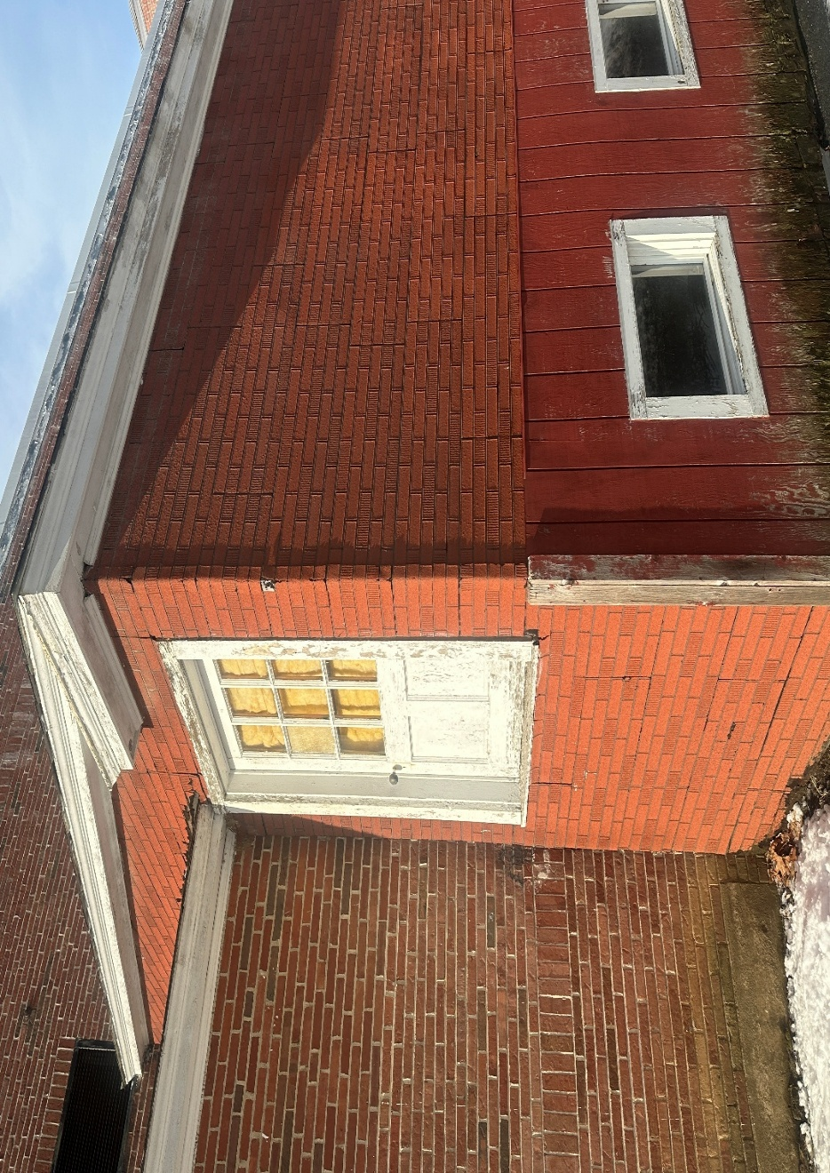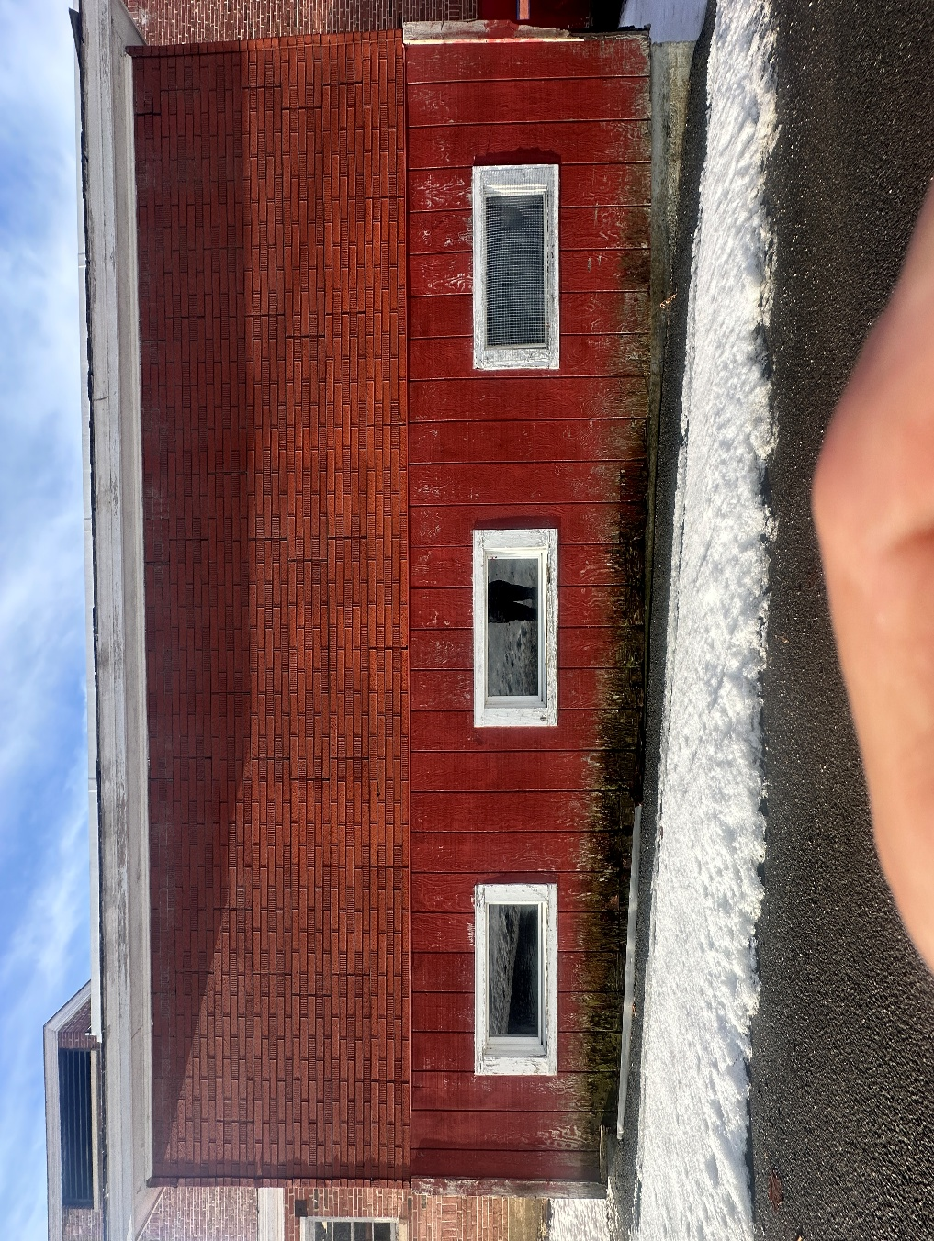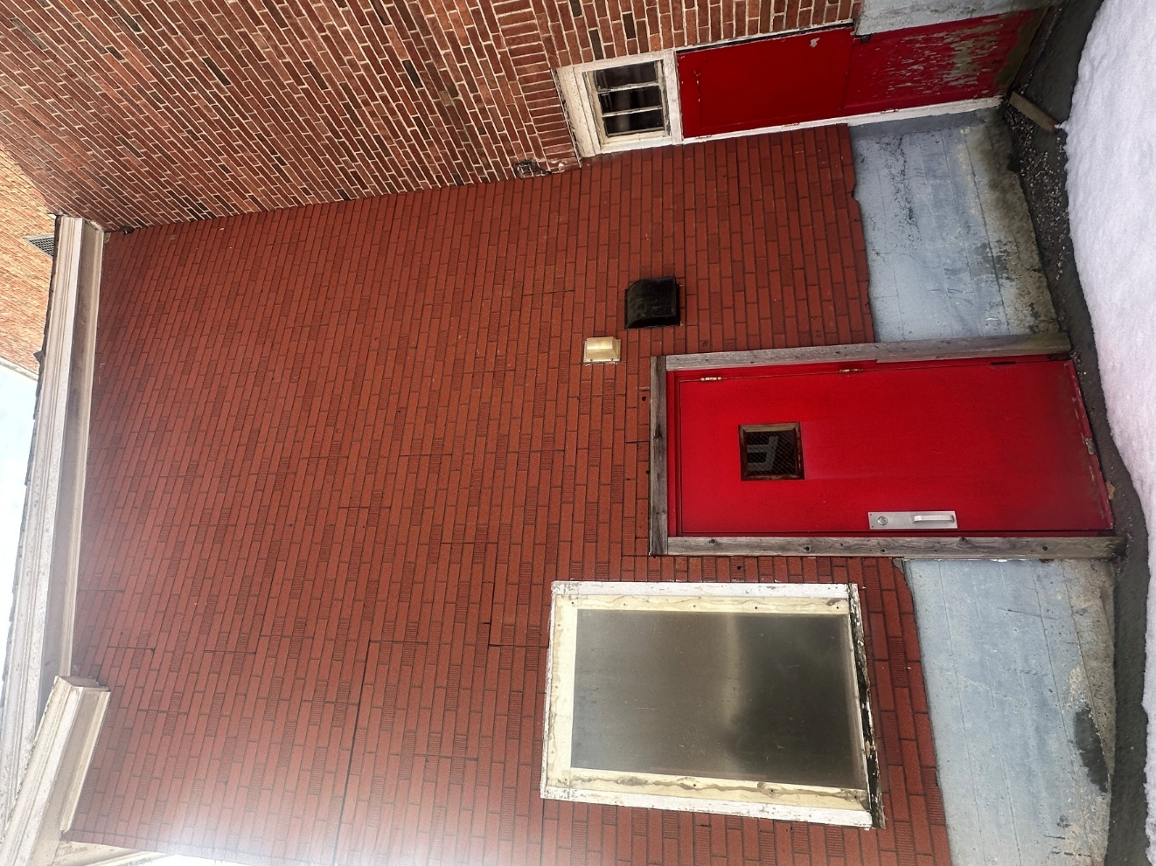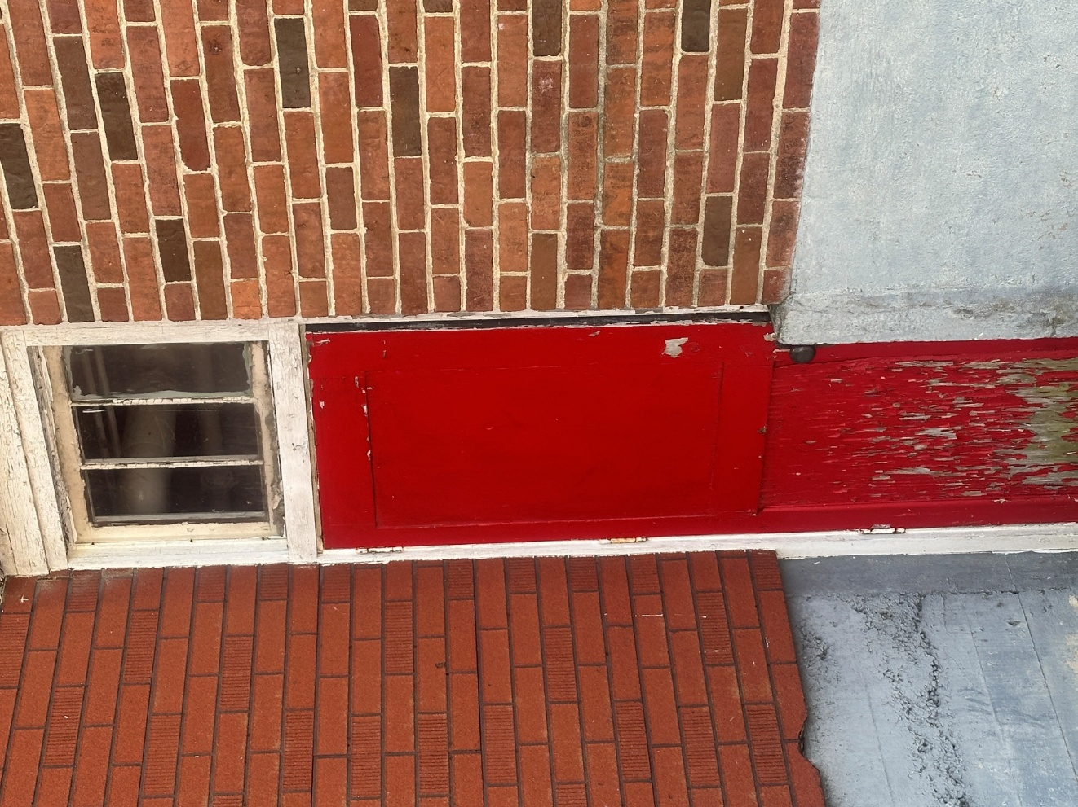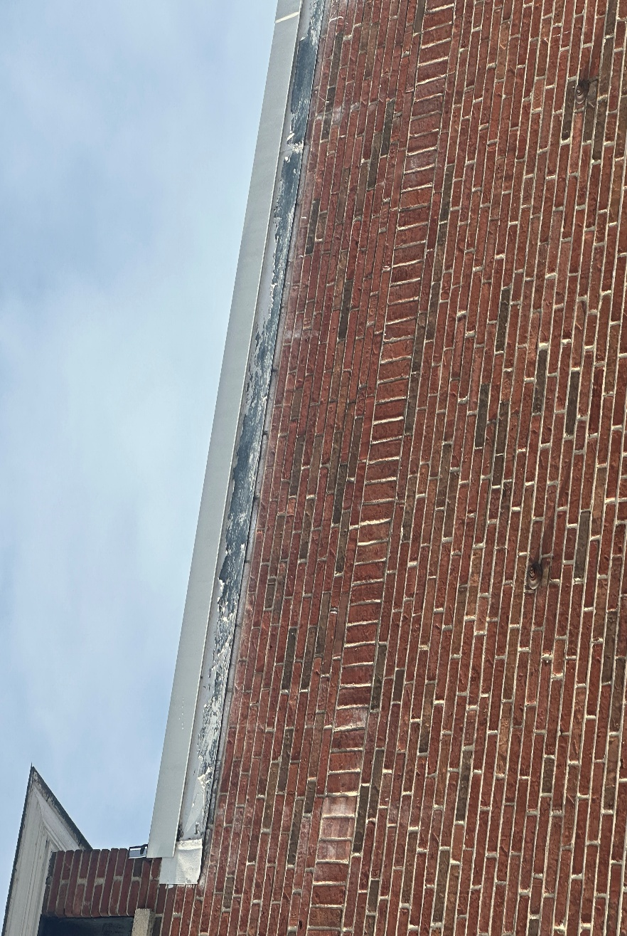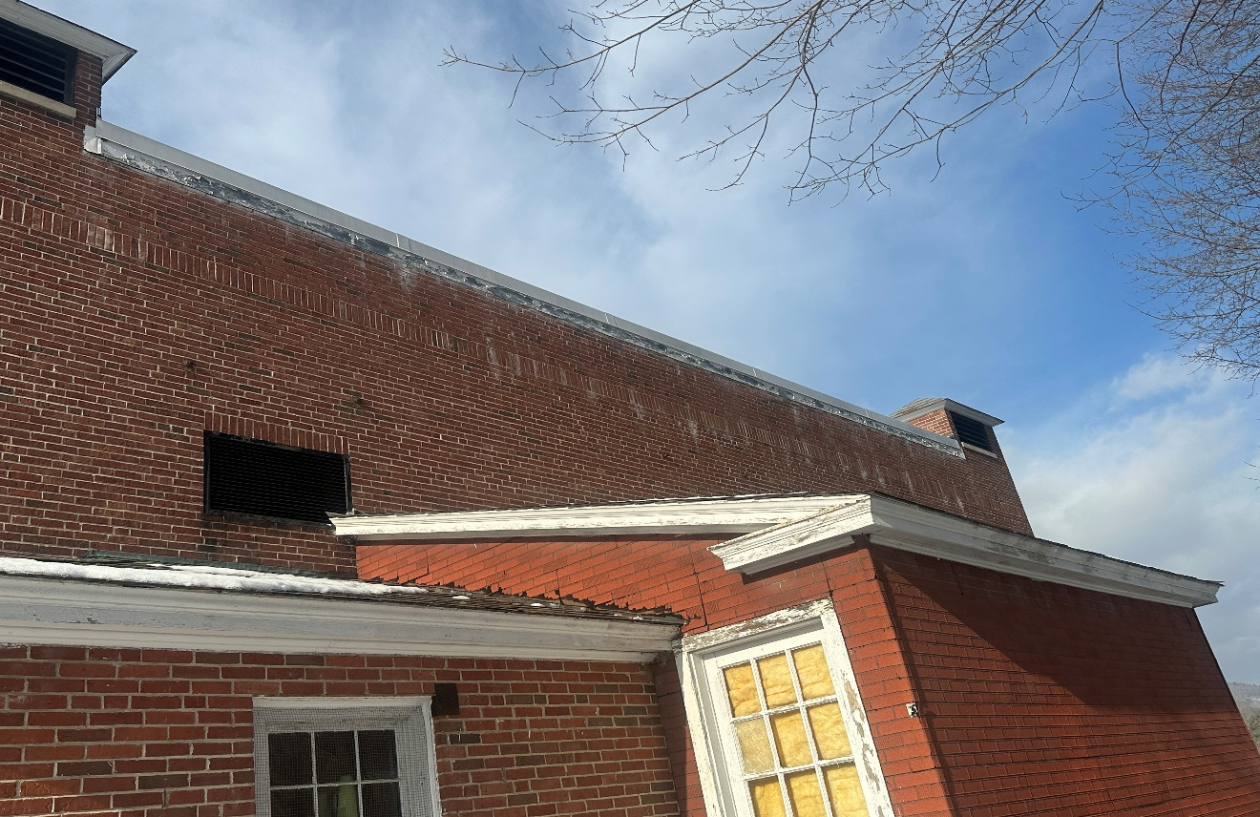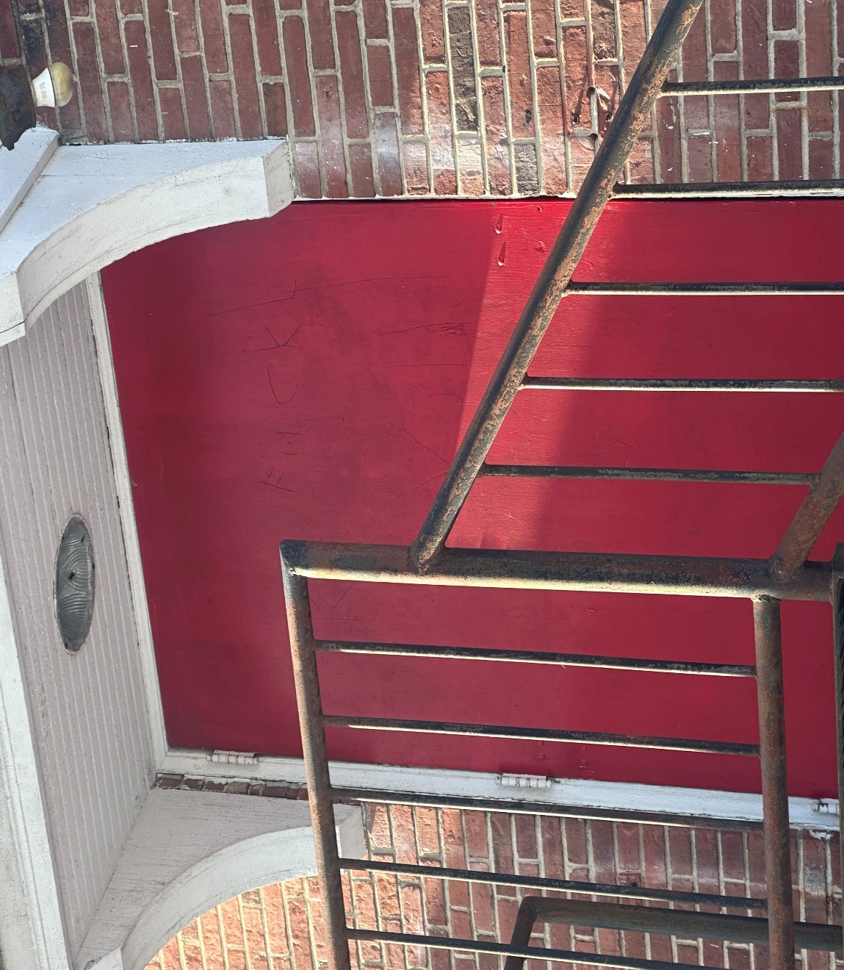

1.02 Product Requirements
1.03 Delivery, Storage and Handling
A. Materials shall be protected from the weather and other damage.
C. Damaged materials found unsuitable for use will be rejected and shall be removed from the site.
1.04 Project, Site Conditions
1.05 Cleaning
A. After completion of work in an area, equipment shall be removed, and all surfaces shall be cleaned of all deposits of material.
GENERAL CONDITIONS
DEFINITIONS: Where “Cowell Gymnasium Project Coordinator,” “Awarding Authority” or “Town” is used, it shall mean the Town of Shelburne or their designee.
SUMMARY: The work consists of supplying and installing energy efficient improvements at the Cowell Gymnasium per the plans and specifications provided.
The Work of the contract shall consist of all construction materials, labor, equipment, and services required by the specifications and other documentation, or as reasonably inferable from any or all the Construction Documents. The Work shall be for the whole of the project as described in the Construction Agreement.
The Work of the project shall comply in all respects with applicable federal, state, county and/or town regulations, laws, and codes. All required building and other permits shall be obtained before beginning construction.
All materials and workmanship shall be equal to the highest standard and shall be to the satisfaction of the Cowell Gymnasium Project Coordinator. Substitution of items will not be permitted unless specifically approved by the Cowell Gymnasium Project Coordinator in writing.
EXAMINATION OF DOCUMENTS AND SITE: Before submitting a bid, each bidder shall read the Specifications and all other Bidding Documents. Each bidder shall fully inform himself/herself prior to bidding as to existing conditions and limitations under which the Work is to be performed and shall include in their bid a sum to cover the cost of items necessary to perform the Work as set forth in the proposed Contract Documents.
No allowance will be made to a bidder because of lack of such examination or knowledge. The submission of a bid will be considered as conclusive evidence that the bidder has done such an examination.
HAZARDOUS MATERIALS/ STOP WORK: If hazardous-containing materials are encountered during this work the Contractor shall cease removal work and immediately notify the Cowell Gymnasium Project Coordinator. Town-approved Work Stoppages will not apply to the deadline.
PROJECT MEETINGS: Unless otherwise directed by the Town, project meetings will be held to review project progress. Present at these meetings shall be a representative authorized to make commitments for action on behalf of the Cowell Gymnasium Project Coordinator, and the Contractor. The Cowell Gymnasium Project Coordinator shall write minutes of all meetings and distribute them within 72 hours of the meeting to all parties present and to those on the distribution list given out at the orientation meeting. The Contractor shall revise the schedule weekly and shall bring the revised schedule with a detailed week look ahead to each project meeting.
CONSTRUCTION TIME: The Agreement includes a stipulation that the Work be entirely completed within 8 weeks of execution of contract.
BUILDING PERMIT: It is the responsibility of the Contractor to apply for and secure a building permit for the Work if necessary. The Contractor is responsible for contacting the Town of Shelburne ’s Building Inspector for timely and required inspections of the Work. The permit fee for this work shall NOT be waived by the Town.
ACCESS TO BUILDING: Contractor shall be allowed access to the building and there will be no requirement for a Town representative to be on site. The Contractor shall assure that the building is secured and will use utmost care in always protecting Town-owned property.
ELECTRICAL SERVICE INTERRUPTION: Contractor may interrupt electrical service with planned notice to be given to the Town representative.
MODIFICATIONS: All requests to modify the project scope, specifications or drawings shall be submitted in writing by the Contractor and must be approved by the Cowell Gymnasium Project Coordinator in writing.

GENERAL SPECIFICATIONS
CONTRACT DOCUMENTS AND RELATED REQUIREMENTS:
The following specifications are considered minimum requirements for proper completion of the Work as described by the Documents. Provide all necessary permits, labor, materials, equipment, debris and demolition removal, safety procedures and supervision and all Project and Contract Closeout requirements and procedures.
• General provisions of the contract, including any supplementary conditions and other included specifications shall apply to the work of this project. The Documents show the work to be done under the contract and related requirements and conditions impacting the project. Related requirements and conditions include applicable codes and regulations, notices and permits, existing building conditions and restrictions on use of the building/site, requirements for Cowell Gymnasium occupancy during the work, coordination with other work and the phasing of the work. In the event the Contractor discovers a conflict in the contract documents and/or requirements or codes, the conflict must be brought to the immediate attention of the Cowell Gymnasium Project Coordinator for resolution. Whenever there is a conflict or overlap in the requirements, the most stringent shall apply. Any actions taken by the Contractor without obtaining guidance from the Cowell Gymnasium Project Coordinator shall become the sole risk and responsibility of the Contractor. All cost incurred due to such action are also the responsibility of the Contractor.
CONTRACTOR(S):
• The Contractor shall be solely responsible for the Work described in the contract agreement. S/he shall have complete control over construction methods, techniques and procedures and shall supervise such work with her/his best skill and attention. The Contractor shall pay for all labor, equipment, materials, and services required to complete the Work as described in the Contract Agreement as well as building permits and other governmental fees, licenses, and inspections necessary for the proper completion of the Work.
• The Contractor warrants that all materials and equipment required to complete the Work on the project will be of excellent quality and new.
• The Contractor shall take care in working near existing areas to protect them from damage. The Contractor shall be responsible for any damage to existing areas and will repair such damage, at their expense, to the Cowell Gymnasium Project Coordinator’s satisfaction.
• The Contractor shall keep the project site and surrounding area free from waste materials and rubbish which results from his work on the project. Providing a dumpster in the Cowell Gym parking lot area, removal, hauling and disposal of rubbish and waste materials shall be the responsibility of the Contractor. Costs for dumpster and hauling shall be included in the lump sum fee.
• The Contractor shall be held responsible for all damage resulting from his, or his subcontractors, errors, omissions, or negligence in the performance of the Work of the Construction Agreement.
• The Contractor shall hold harmless the Town and Cowell Gymnasium Project Coordinator from and against all claims, damages, losses, expenses, legal fees, or other costs resulting from the Contractor's performance of the Work of the Construction Agreement.
SUBCONTRACTORS:
• The Contractor shall select the subcontractors, except that he shall not use subcontractors to whom the Cowell Gymnasium Project Coordinator has a reasonable objection. The Contractor shall not be required to use a subcontractor to whom he has a reasonable objection.
OSHA:
• The work area shall be made OSHA safe by this Contractor. All workers must be OSHA trained and carry their OSHA cards.
JURISDICTION:
• This agreement shall be governed by the laws of the Commonwealth of Massachusetts.
CONTRACTOR USE OF PREMISES:
• The Contractor and Contractor's personnel, subcontractors and others providing portions of the Work of the project shall cooperate fully with the Cowell Gymnasium Project Coordinator regarding the use of the building to facilitate the Work.
PROJECT CHANGES:
• Changes, modifications, additions, and/or deletions to the Work under this agreement will only be made by a written order signed by the Cowell Gymnasium Project Coordinator and the Contractor. Any such changes will not invalidate this Agreement. The time for project completion and the project cost will be adjusted accordingly.
PERSONNEL PROTECTION:
• The Contractor is responsible for all safety and protection of all persons at the site of the Work including following all current Massachusetts COVID Workplace protection protocols.

Price Quote Form
Tab Room Shelburne Cowell Gymnasium COMMBUYS RFQ 127361
Pricing is according to the specifications provided within this Request for Price Quotes. All activities not expressly mentioned in these specifications, but involved in conducting their intent are required, and the contractor shall perform the same as though they were specifically mentioned, described, and delineated. Project will be Completed within Ninety (90) days from Contract Execution

Total Lump Sum Price Quote with Wood Clapboards $____________________________________
Total Lump Sum Price Quote with Cement Board Clapboards $_________________________________
Per window fee for carpentry modifications: $_________________________________
Hourly rate for unforeseen carpentry modifications: $_________________________________

The Bidder certifies that all materials meet or exceed all the requirements of the price quote specifications, that they are properly licensed and have been in business for at least three years, and a representative of their company has visited the site and made appropriate measurements and assessments of the existing conditions.

Signature ___________________________
Printed Name ________________________________________________
Title__________________________

Company Name_______________________________
Company Address _______________________________________________________

Phone _________________ Fax _______________
Email __________________________________________
Date_____________________

Please initially if you have received any Addenda:
#1 _______________ #2 ________________ #3 ________________

NON-COLLUSION STATEMENT
Any person or corporation that fails to date, sign their original signature, and submits the following statements shall not be awarded this contract.
Certificate of Non-Collusion
The undersigned certifies under penalties of perjury that this quote has been made and submitted in good faith and without collusion or fraud with any other person. As used in this certification, the work “person” shall mean any natural person, business, partnership, corporation, union, committee, club, or other organization, entity, or group of individuals.

Date ____________________________________________
Authorized Official’s Signature
____________________________________________
Typed or Printed Name of Person Signing
____________________________________________
Company or Corporation

OSHA CERTIFICATION
I hereby certify that all our employees who will be employed at the work site have successfully passed the OSHA approved 10-hour safety course, and we have proof on file. I also certify that I can furnish labor that can work in harmony with all other elements of labor employed or to be employed in the work.
Date _______________________________________________
Authorized Official’s Signature
____________________________________________
Typed or Printed Name of Person Signing
____________________________________________
Company or Corporation

REFERENCES
Please list AT LEAST THREE references, preferably for projects of comparable size and scope and for a public entity. Please make sure contact information is CURRENT. Inability to check references may affect the eligibility of your bid. You may use your own form if it includes at least all this information.
1______________________________________________________________________
Name of Contact Person Phone Number
2______________________________________ ___________________________________
Name of Contact Person Phone Number
3______________________________________ ___________________________________
Name of Contact Person Phone Number

CHECK LIST FOR REQUIRED SUBMITTALS

__ Completed and Signed Price Quote Form
__ Signed Non-Collusion Statement
__ Signed OSHA Statement
___ References

YOU MUST SCAN AND SEND YOUR PRICE QUOTE VIA EMAIL TO:
townadmin@townofshelburnema.gov
Do not forget to include an authorized signature where shown.

Sample Contract
A contract in accord with the terms and conditions which follow will be needed from the winning bidder. Any questions or requests for change must be received by the TOWN OF SHELBURNE (townadmin@townofshelburnema.gov) before the deadline for written questions for consideration.
TERMS AND CONDITIONS OF THE TOWN OF SHELBURNE ’S STANDARD CONTRACT FOR SERVICES
ENGAGEMENT OF THE CONTRACTOR/ SERVICE PROVIDER
• (hereinafter termed “Contractor”)- Contractor agrees to perform the work described in the Purchase Order or Contract and attachments (PO). In performing the services under this Agreement, the Contractor shall be considered independent and not an employee of the Town.
- The Town may end, in writing, this Agreement for non-performance of services required including the progress of work for services. Town may end the contract for convenience with written notice. Upon receipt of written notification from the Town to the Contractor that the Agreement or any portion thereof is to be terminated, Contractor shall immediately cease operations on the work, and assemble all material that has been prepared, developed, furnished or obtained under the Agreement that may be in the possession or custody of the Contractor and shall transmit same to the Town on or before the 10th day following receipt of the written notice of termination together with evaluation of the cost of work performed.
- The contractor shall be entitled to complete payment for satisfactorily completed uncompensated work performed prior to such notice and for the cost of assembling the material to be transmitted to the Town. If there is a disagreement between Contractor and the Town, the terms of this Agreement shall control.
SERVICES AND RESPONSIBILITIES OF THE CONTRACTOR –
• Contractor shall serve as the professional representative of the Town during the project and will consult with and advise the Town during performance of services. Contractor shall receive prior approval from the Town for any expenditure not specifically provided for in this Agreement, which is thought to be billable. Contractor is advised that work undertaken within the terms and provisions of this Agreement shall be with the full knowledge and consent of the Town and any work performed outside the Services listed on the PO without the prior written agreement of the Town, shall not be considered as work under this Agreement and payment for such work may not be allowed. The contractor shall complete all work specified on the PO or any attachment thereto. Records of the Contractor pertinent to this Agreement shall be kept for a period of not less than seven (7) years (MGL c. 4 § 7).
SCHEDULE –
• Services as required under this Agreement shall be completed by the Contractor according to the dates on the PO/Contract.
RESPONSIBILITIES OF THE TOWN
• The Town shall make available to the Contractor available information pertinent to the project including background information on file at the Town Office.

PAYMENTS TO THE CONTRACTOR –
• For all services to be performed under this Agreement, Contractor shall be compensated in accordance with invoices sent by the Contractor to the TOWN. The contractor shall invoice in two phases, one for 50% of the total amount upon signing the contract with the Town and the final 50% upon successful acceptance of the project. The invoice should document dates of services, and a description of services given. Contractors will provide their own supplies and materials. Materials bought at a direct cost outside this agreement will become property of the Town and must have prior approval. Town is not subject to sales tax. A Federal W-9 Form must be sent with the signed contract. The Town fiscal year ends June 30. Invoices for work at the end of the fiscal year must be received within ten calendar days (July 10), even if PO is still “open”.
SEVERABILITY & APPLICABLE LAW –
• In the event that any provision of this Agreement shall be deemed invalid, unreasonable or unenforceable by any court of relevant jurisdiction, such provision shall be stricken from the Agreement or modified so as to render it reasonable, and the remaining provisions of this Agreement, or the modified provision as provided above, shall continue in full force and effect and be binding upon the parties so long as such remaining or modified provisions reflect the intent of the parties as of the date of this Agreement. Further, should this Agreement omit any statutory or regulatory requirements which would otherwise make this Agreement illegal, then this Agreement shall be considered amended to the minimum extent necessary to follow said statues or regulations. This Agreement shall be construed in accordance with the laws of the Commonwealth of Massachusetts and any suit brought pursuant to this Agreement shall be commenced only therein.
INSURANCE REQUIREMENTS –
• Contractor shall keep in full force and effect the minimum levels of insurance by insurers acceptable to the Town indicated in the Request for Quotes and before commencement of work. The contractor agrees to provide certificates of insurance to the Town that such insurance has been procured and is in force. Town shall be named additional insured under the liability insurance. General liability insurance policy should contain broad form general liability endorsement.
AMENDMENTS/MODIFICATIONS-
• No amendment or modification to this Agreement shall be effective unless it is in writing, signed by the duly authorized representatives of both parties, complies with the provisions of this Agreement, and all other regulations and requirements of law.
INDEMNITY
a. To the fullest extent permitted by law, Contractor shall defend, indemnify, and save harmless the Town and its respective duly elected or appointed officials, agents and employees from and against all demands, claims, damages, liabilities, losses, costs, and expenses (including, but not limited to, reasonable attorney fees) (referred to collectively as “demands”) arising out of or resulting from any work performed pursuant to this Agreement including but not limited to any negligent acts, errors, or omissions of the Contractor, any sub-Contractor of the Contractor, or any person directly or indirectly employed by any of them, or by a defect of a product or design supplied by the Contractor or sub-Contractor. Such obligations shall not negate, abridge, or reduce in any way any additional indemnification rights of the Town that otherwise may exist under statute or in law or equity.
b. The Contractor shall defend, indemnify, and hold harmless the Town from any and all demands relating to wages, overtime compensation, or other employee benefits by employees employed directly or indirectly by the Contractor for work performed in connection with the work hereunder or required by state or federal law, including but not limited to Fair Labor Standards Act and Massachusetts Prevailing Wage Law.
c. The indemnification obligations of the Contractor and sub-Contractor shall not be limited in any way by any limitations on the amount or type of damages, compensations, or benefits payable by or for the Contractor or sub-Contractor under any federal or state law.
d. In the event of a breach of this Agreement by the Contractor, the Contractor shall pay the Town all reasonable attorney fees, costs and other litigation expenses incurred by the Town in enforcing its rights because of said breach in addition to any damages for said breach.
ASSIGNABILITY-
- The Contractor shall not assign any interest to this Agreement, and shall not transfer any interest in the same, without prior written consent of the Town. No subcontract may be awarded by the Contractor, the purpose of which is to provide in whole or in part the services required herein, without said written consent of the Town. Nothing herein shall be construed to prevent an assignor’s due performance of its entire obligation.
CONFLICT OF INTEREST-
- The Town and the Contractor shall take all reasonable actions necessary to ensure that their officers, employees, agents, and members of their governing bodies are aware of the requirements, and comply with the provisions of MGL, Chapter 268A, the so-called Conflict of Interest Law.
NONDISCRIMINATION-
- Contractors shall not discriminate against any person because of race, color, religious creed, national origin, gender, ancestry, sexual orientation, age, handicap, gender identity, genetic information, military service, or any other protected class under the law.
WEEKLY PAYROLL RECORDS REPORT & STATEMENT OF COMPLIANCE
- In accordance with Massachusetts General Law c. 149, §27B, a true and accurate record must be kept of all people employed on the public works project for which the enclosed rates have been provided. A Payroll Form required to be kept by law. Every contractor or subcontractor is required to keep these records and preserve them for a period of three years from the date of completion of the contract.
- In addition, every contractor and subcontractor are required to submit a copy of their weekly payroll records to the awarding authority. This is required to be done on a weekly basis. Once collected, the awarding authority is also required to preserve those records for three years from the date of completion of the project.
- Each such contractor or subcontractor shall furnish to the awarding authority directly within 15 days after completion of its portion of the work, a statement, executed by the contractor, subcontractor or by any authorized officer thereof who supervised the payment of wages, this form.

STATEMENT OF COMPLIANCE
I, ___________________________________, ___________________________________
(Name of signatory party) (Title) do hereby state:
That I pay or supervise the payment of the people employed by
___________________________________ on the ______________________________
(Contractor, subcontractor, or public body) (Building or project) and that all mechanics and apprentices, teamsters, chauffeurs, and laborers employed on said project have been paid in accordance with wages determined under the provisions of sections twenty-six and twenty-seven of chapter one hundred and forty-nine of the General Laws.

Signature _________________________

Title ______________________________

